**Design Patterns Explained**

A New Perspective on Object-Oriented Design

Alan Shalloway, James R. Trott

Second Edition

<http://www.netobjectives.com/resources/books/design-patterns-explained>

<http://www.netobjectives.com/resources/books/design-patterns-explained/annotated-table-of-contents>

<http://www.netobjectives.com/resources/books/design-patterns-explained/review-questions>

**Preface**

Patterns are supposed to be sewn together to solve a problem.

**The Timeless Way of Building** - Christopher Alexander

[Pattern Language](https://en.wikipedia.org/wiki/Pattern_language)

Jim Coplien works on commonality & variability analysis (CVA)

Martin Fowler works in methodologies & analysis patterns

eXtreme Programming (**XP**) coding practices

Test Driven Development (**TDD**)

Knowledge Analysis & Design Support (KADS)

**Martin Fowler, Ken Schwaber, Ward Cunningham, Robert Martin, Ron Jeffries, Ken Beck, Bruce Eckel**

**Part 1 - An Introduction to Object-Oriented Software Development**

**Chapter 1 - The Object-Oriented Paradigm**

Functional decomposition

- natural way to deal with complexity

- the analyst breaks down (decomposes) the problem into the functional steps that copse it

- the challenge is that the main program will have too much responsibility, the code becomes too complicated

- doesn’t help us prepare the code for possible changes in the future - issues encountered when you implement everything into one function or module

[Problem domain](https://en.wikipedia.org/wiki/Problem_domain)

“There is always time to program it right the SECOND time, so you might as well do it right the FIRST time.”

Issues that might be encountered => weak cohesion, tight coupling

**Code Complete** - Steve McConnell

Cohesion = how closely the operations in a routine are related (to each other)

- “Clarity” => the more the operations are related in a routine (or a class), the easier it is to understand things

- weakly cohesion classes => those that do many, unrelated tasks; god objects, as they do everything

Coupling = the strength of a connection between two routines.

The goal is to create routines with internal integrity (strong cohesion) & small, direct, visible and flexible relations to other routines (loose coupling)

“The Devil is in the Side Effects”

UML Distilled - Martin Fowler

Perspectives in software development process:

- *conceptual* -> the model is drawn with little or no regard for the software that might implement it (“What am I responsible for?”)

- *specification* -> considering the interfaces of the software, not the implementation (“How am I used?”)

- *implementation* -> the code itself (“How do I fulfill my responsibilities?”)

Communicate at one level (conceptually) while performing at another (implementation) to insulate the requestor from changes in implementation details as long as the concept remains the same.

Using objects shifts responsibility to a more local level.

A good design rule is that objects should be responsible for themselves and should have those responsibilities clearly defined.

**Object-Oriented Software Construction** - Bertrand Meyer (Design by Contract)

Fowler’s perspectives:

-at the *conceptual* level, an object is a set of responsibilities

-at the *specification* level, an object is a set of methods (behaviors) that can be invoked by other objects or by itself

-at the *implementation* level, an object is code and data and computational interactions between them

A class is a definition of the behavior of an object.

At a conceptual level, abstract classes are placeholders for other classes - classes that implement specifics of the concept the abstract class represents. They give us a way to assign a name to a set of related classes.

Encapsulation helps to prevent unwanted side effects.

When I encapsulate something, I am necessarily loosely coupled to it => encapsulation promotes loose coupling.

Constructors => inilialize or set up an object

Destructors/finalizers => clean up an object when it is no longer needed

Polymorphism static => overloading

Polymorphism dynamic => overriding

**Chapter 2 - The UML - The Unified Modeling Language**

The Unified Modeling Language is a visual language (drawing notation with semantics) used to create models of programs (diagrammatic representations of the programs that show the relationships among the objects in the code).

In the analysis phase:

- *case diagrams* => involve entities interacting with the system & the function points that you need to implement

- *activity diagrams* => focus on workflow of the problem domain (the actual space where people & other agents are working, the subject area of the program) rather than the logic flow of the program

Looking at object interactions:

- *interaction diagrams* => show how specific objects interact with each other. They deal with specific cases rather than general situations. Helpful both when checking requirements and when checking designs. (Eg.: sequence diagram)

In the design phase:

- class diagram => the relationships between the classes

Looking at an object’s behavior that differ based on the state that the object is in:

- state diagrams => detail the different states an object may be in as well as the transitions between these states

In the deployment phase:

- deployment diagrams => show how different modules will be deployed

The UML is used primarily for communication - with myself, my team members, my customers. The UML gives us tools to elicit better requirements.

**The class diagram**

- both describes classes & shows relationships among them

Types of relationships:

- one class is a “kind of” another class (the *is-a* relationship)

- one class “contains” another class (the *has-a* relationship)

- one class “uses” another class (the *uses-a* relationship, dependency relationship)

- one class “creates” another class

- composition => the contained item is a part of the containing item (the engine in a car)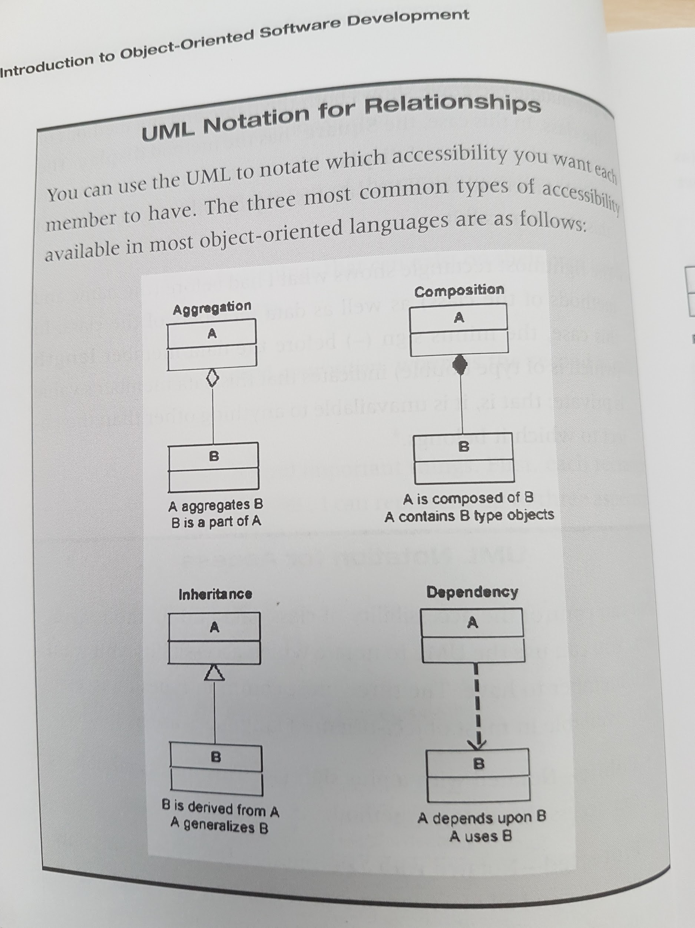

- aggregation => I have a collection of things that can exist on their own (airplanes at an airport)

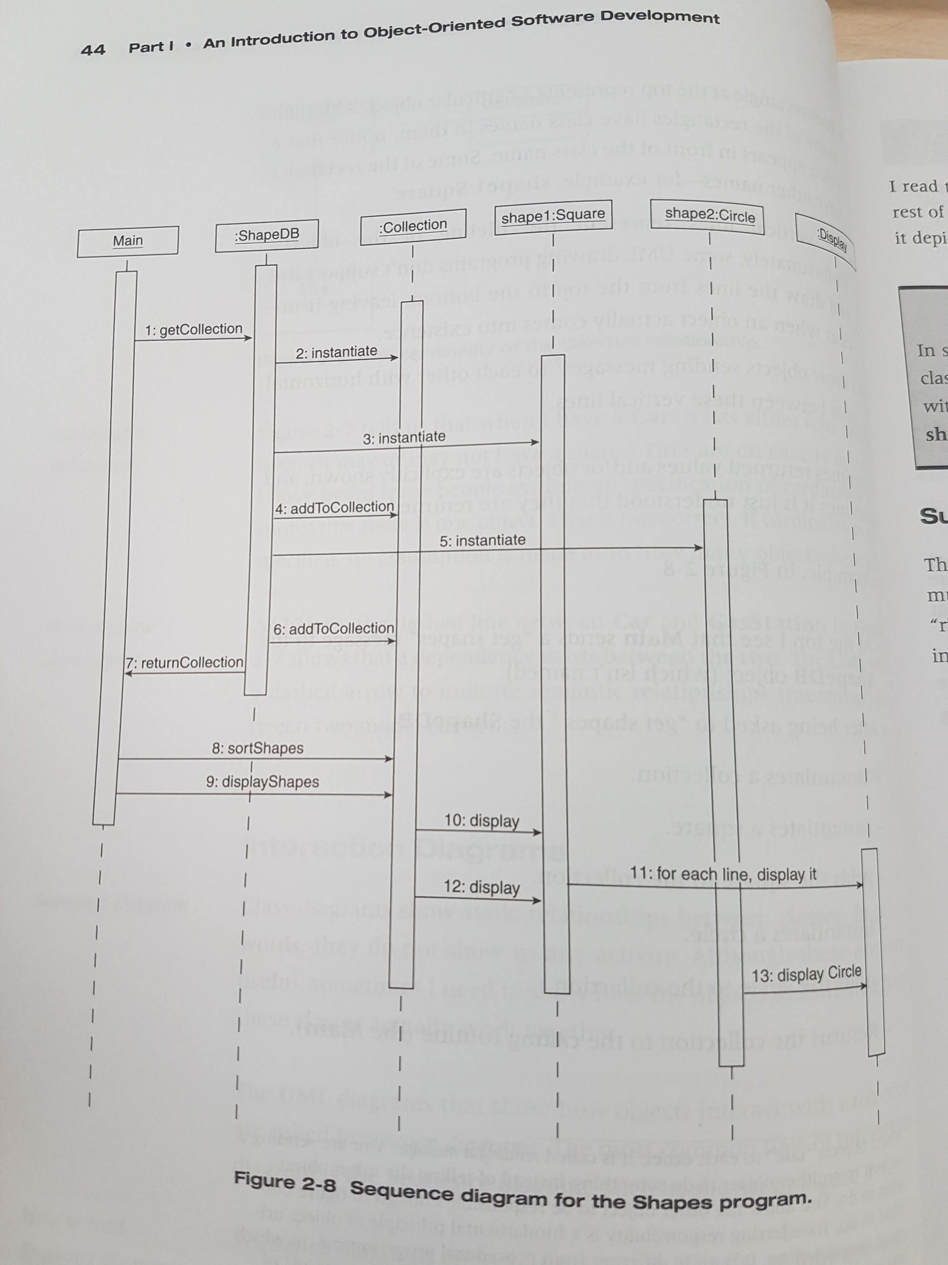

UML notation for access:

-public => +

-protected => #

-private => -

- if the class name is italicized it means it is abstract

- we can consider composition to be an unshared association, with the contained object’s lifetime being controlled by its containing object

-class diagrams show static relationships between classes (they do not show any activity)

**Interaction Diagrams | Sequence Diagrams**

-the sequence diagram depicts the sequence of operations

-shape1:Square => refers to the shape1 object, which is instantiated from the Square class

**Part 2 - The Limitations of Traditional Object-Oriented Design**

**Chapter 3 - A problem that cries out for flexible code**

*Expert system* - a special computer system that uses the rules of a human expert to make automated decisions. First step is to acquire and model the set of rules that experts use to make decisions & accomplish the task. The second step is to implement this set of rules in the computer system.

**Chapter 4 - A Standard Object-Oriented Solution**

**Part 3 - Design Patterns**

**Chapter 5 - An introduction to Design Patterns**

The timeless way of building - Christopher Alexander (arhitectura)

Christopher Alexander’s definition of a pattern = “a solution to a problem in a context” (which occurs over and over again)

Christopher Alexander - A pattern language

Patterns provide context for each other because recognizing a pattern helps clarify the problem itself, making other patterns easier to see.

The four components required of every pattern description:

- the name of the pattern

- the purpose of the pattern, the problem it solves

- how we accomplished this

- the constraints & forces we have to consider in order to accomplish it

Cognitive Patterns: Problem Solving Frameworks for Object Technology - Karen Gardner

Strategies for creating good object-oriented designs (by GoF):

- design to interfaces

- favor aggregation over inheritance

- find what varies and encapsulate it

**Chapter 6 -** [**The Facade Pattern**](https://www.tutorialspoint.com/design_pattern/facade_pattern.htm) **(Structural Pattern)**

[**Wiki**](https://en.wikipedia.org/wiki/Facade_pattern)

Named like this because it puts a new interface (a facade) in front of the original system.

Intent: A unified, high-level interface. You want to simplify how to use an existing system. You need to define your own interface.

The Facade pattern enables us to use a complex system more easily, either to use just a subset of the system or use the system in a particular way. We end up with a simpler, easier-to-use system or one that is customized to our needs.

It hides the complexities of the system and provides an interface to the client using which the client can access the system.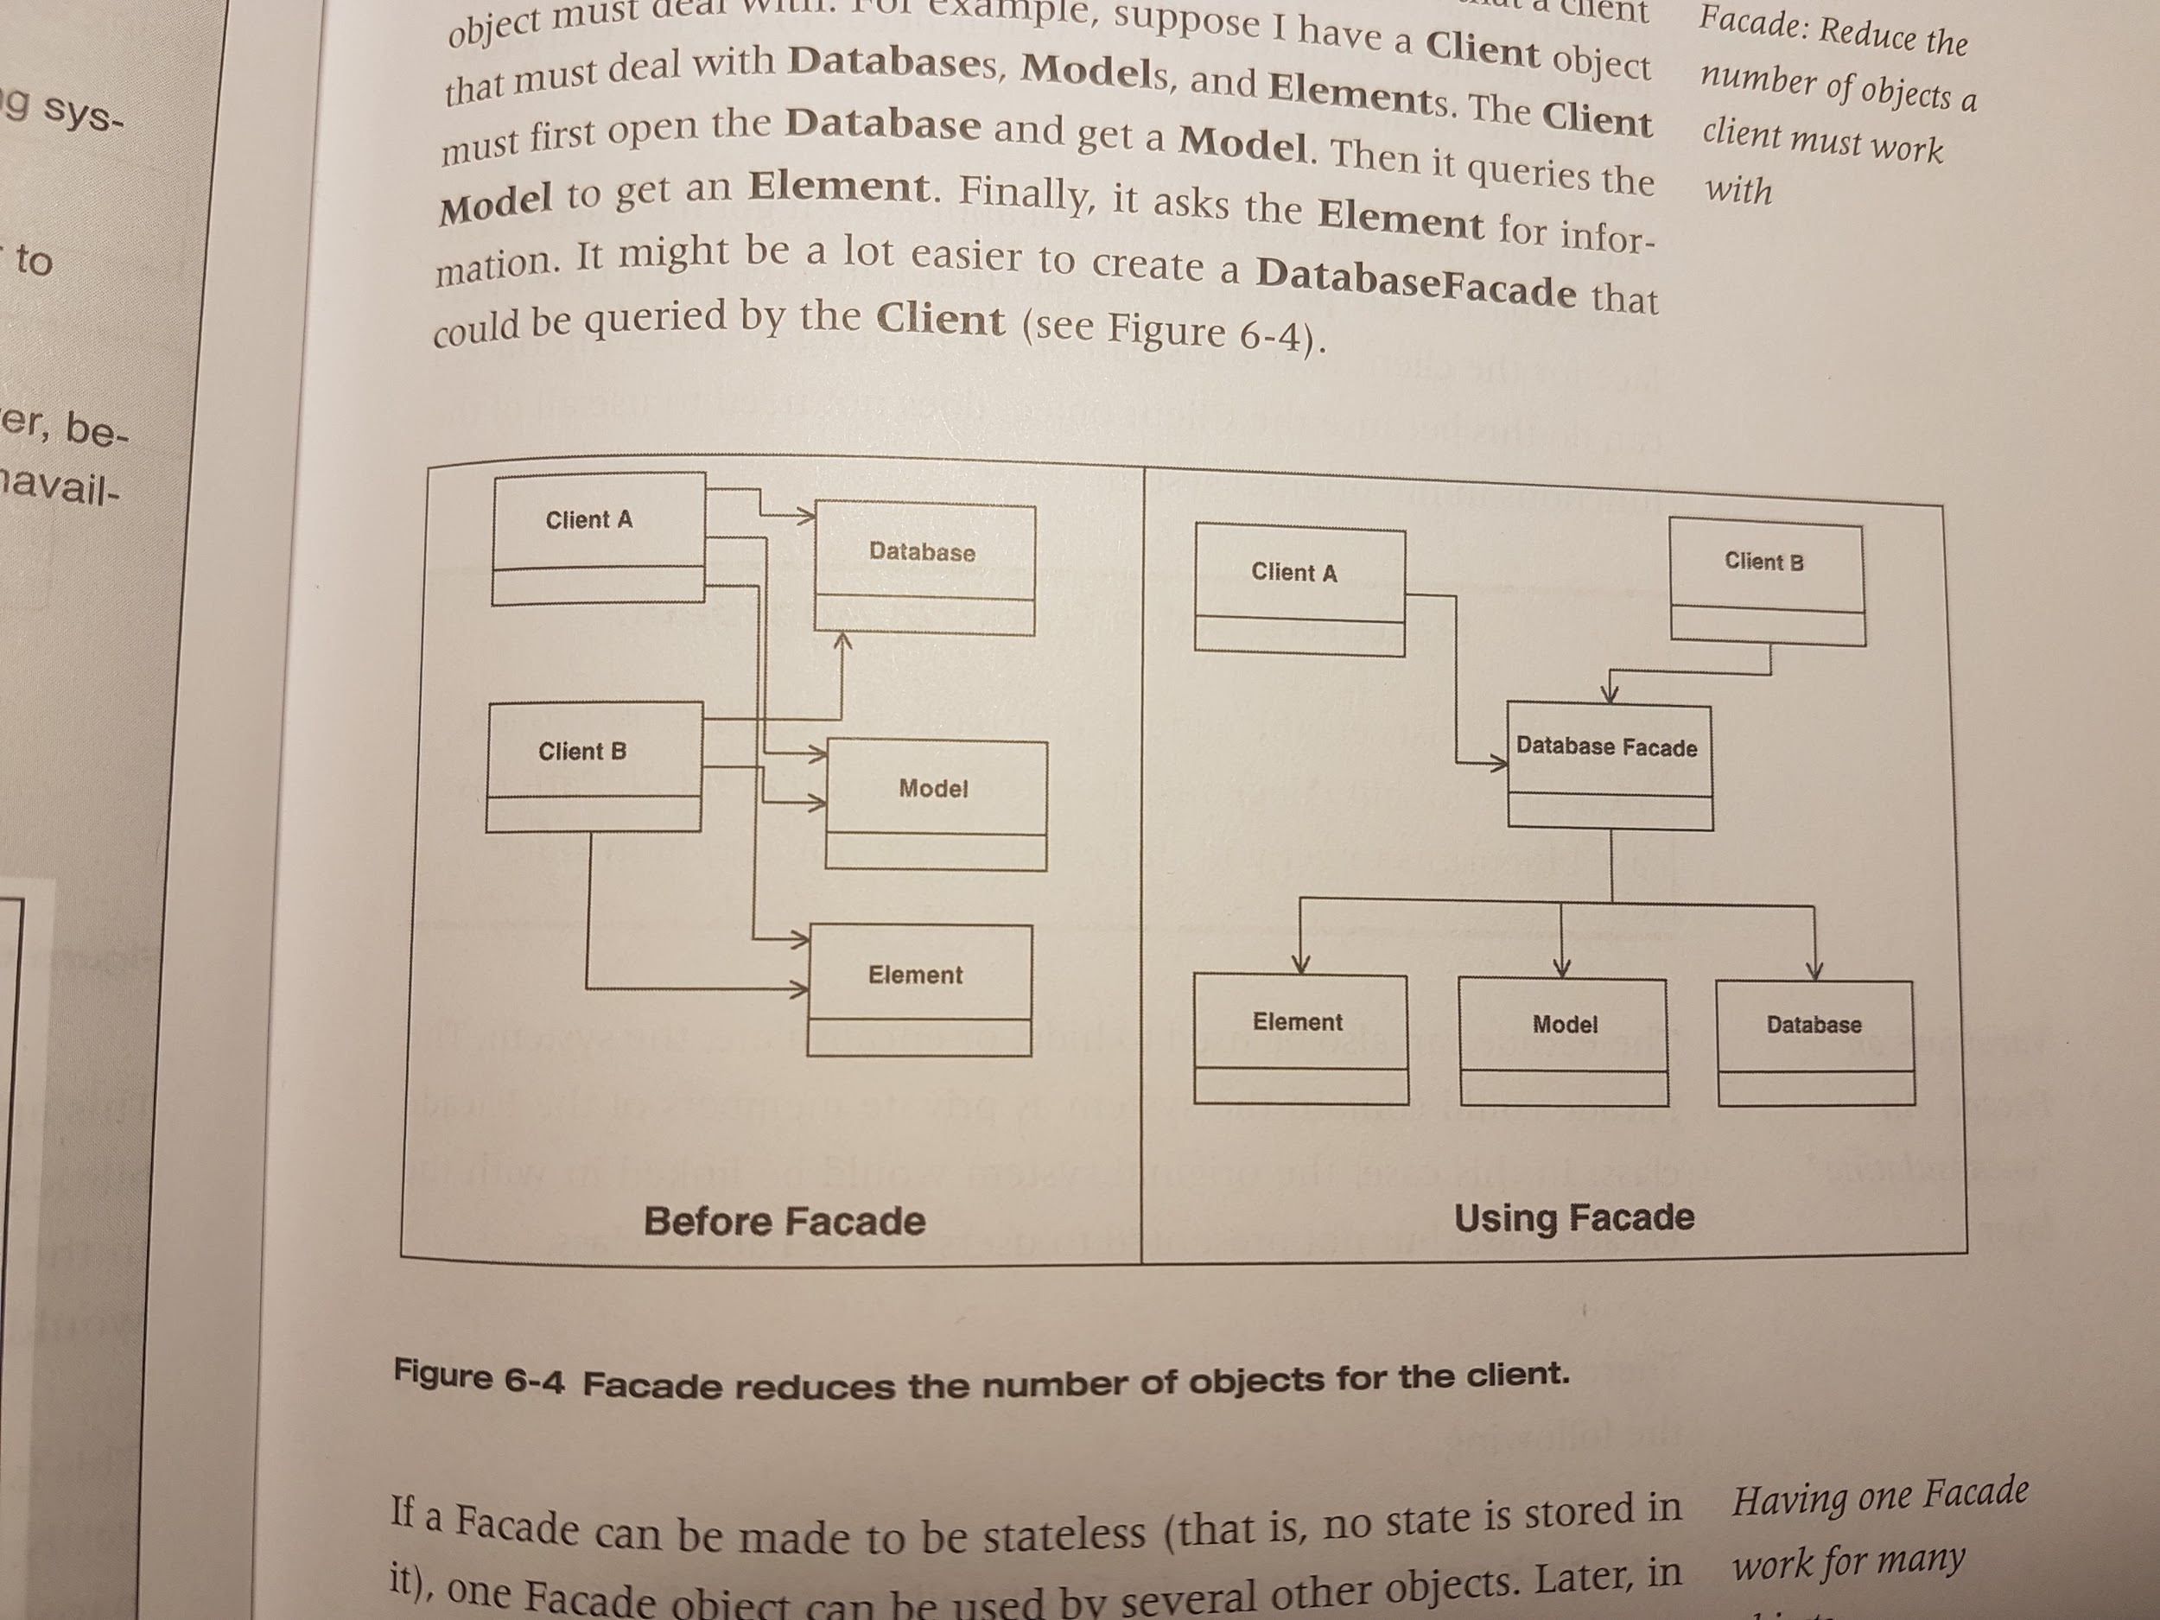

Variations on Facade: Reduce the number of objects a client must work with

Variations on Facade: Supplement existing functions with new routines

Variations: It can be used to hide, or encapsulate, the system (it could contain the system as private members of the Facade class)

Reasons for encapsulation:

-track system usage

-swap out systems (different clients for db, for eg.)

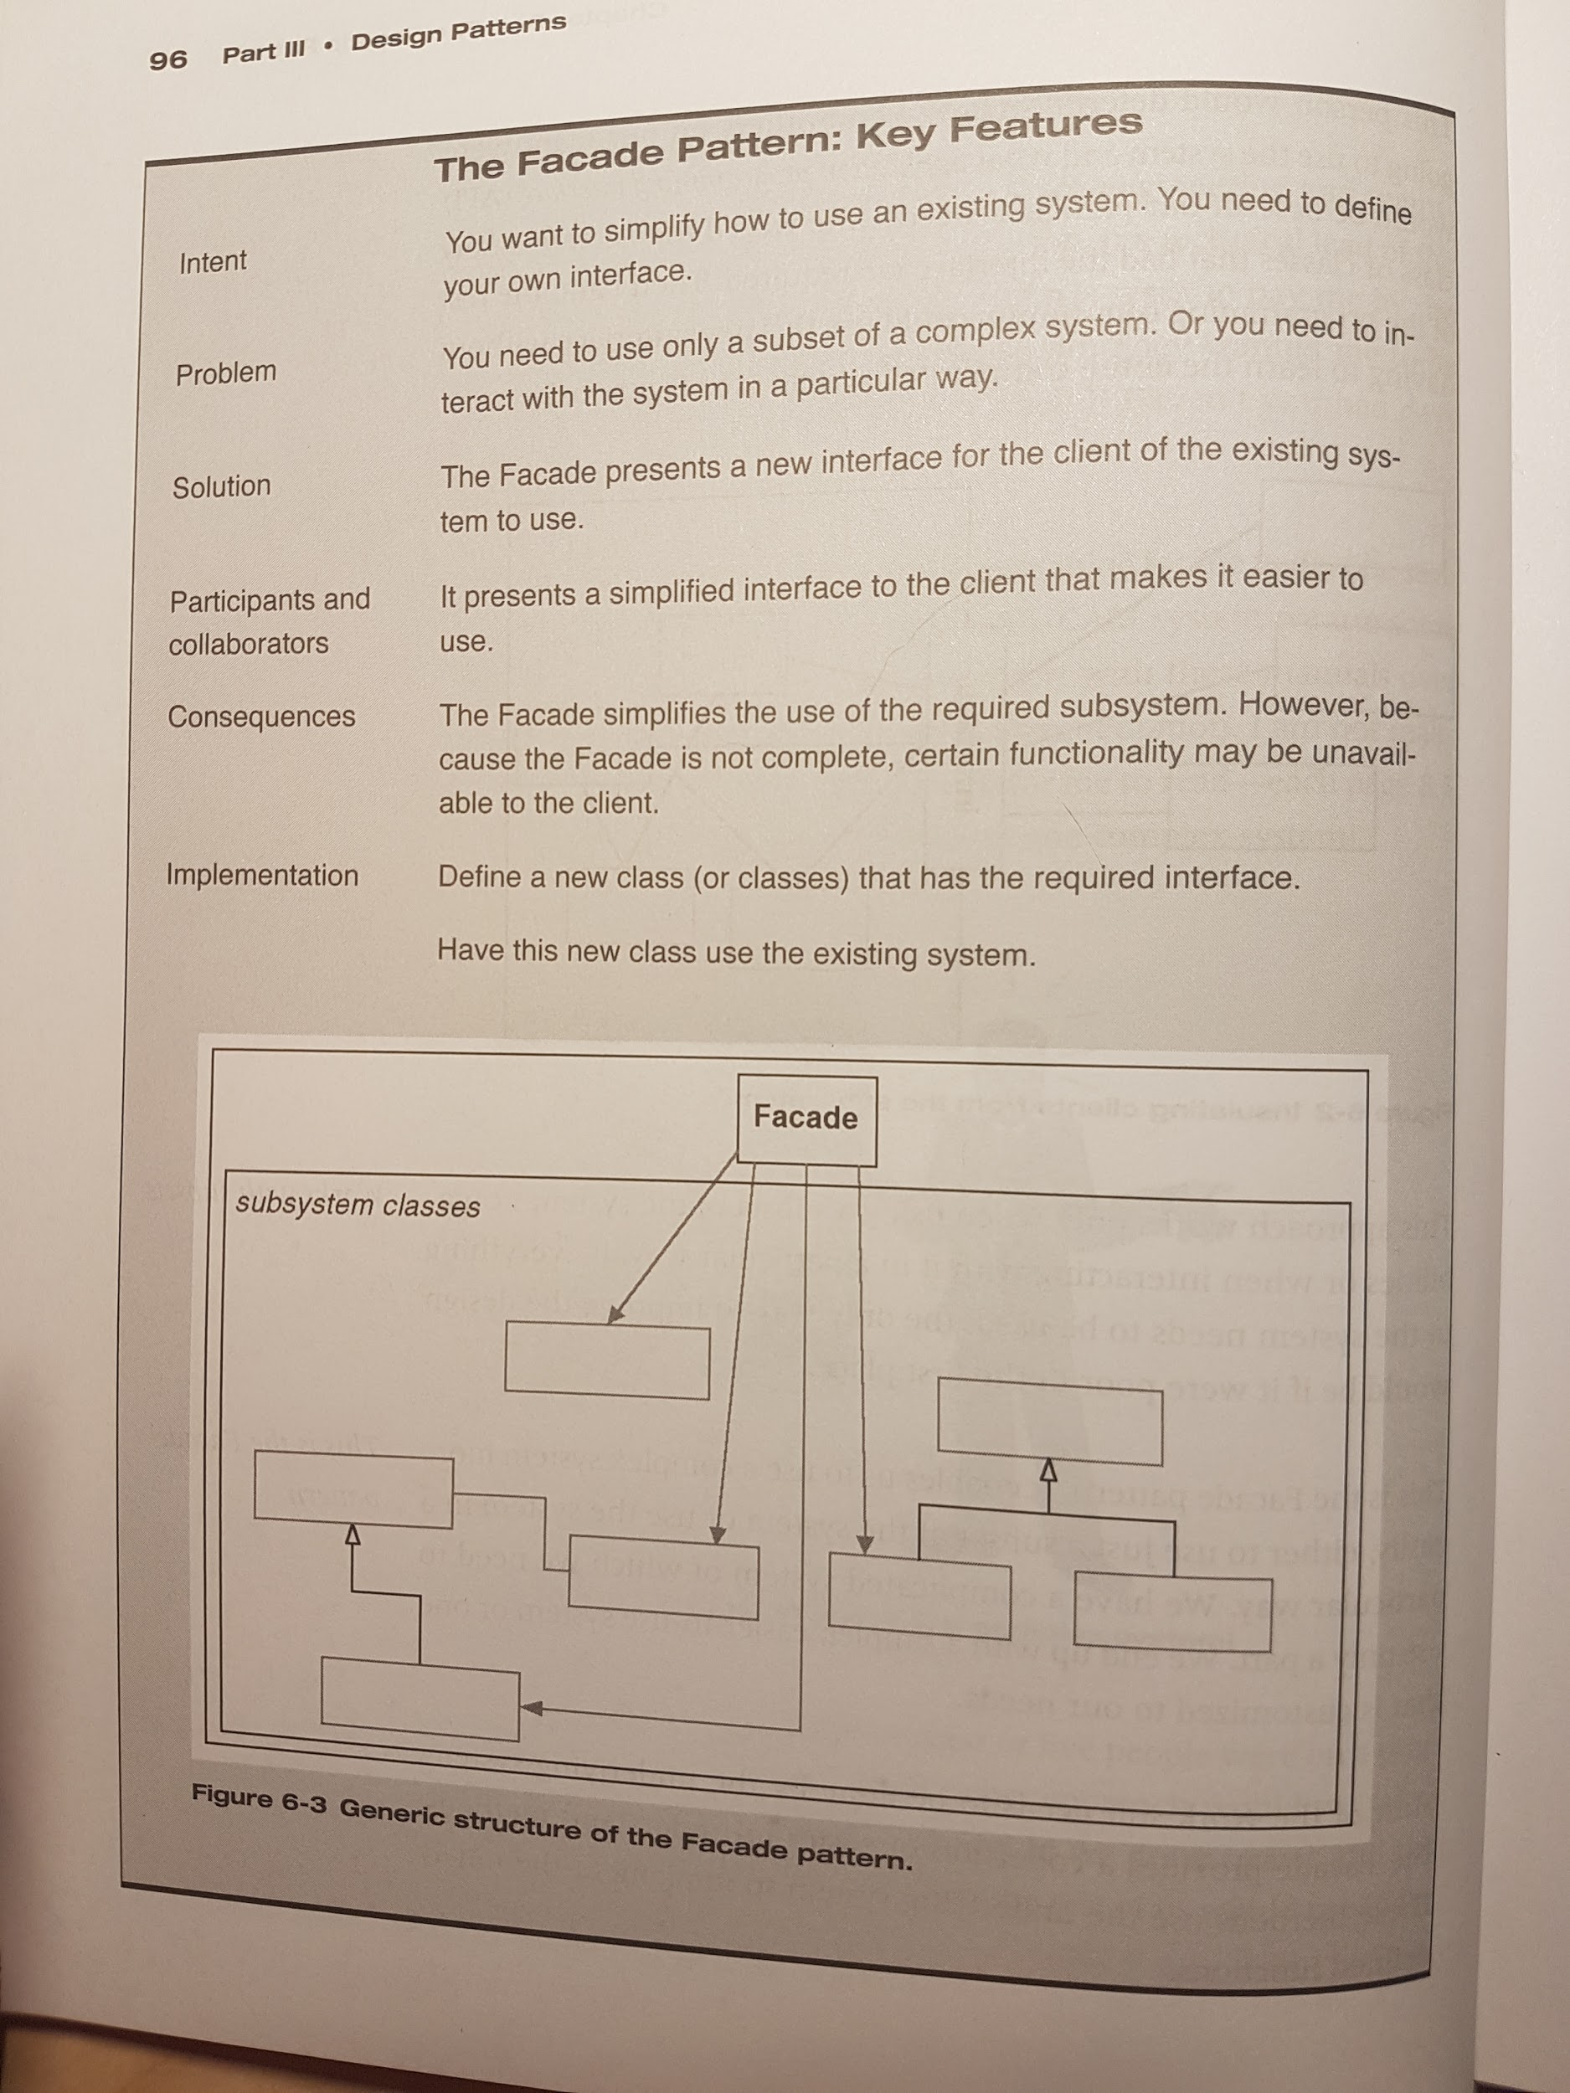

**Chapter 7 -** [**The Adapter Pattern**](https://www.tutorialspoint.com/design_pattern/adapter_pattern.htm) **(Structural Pattern)**

[**Wiki**](https://en.wikipedia.org/wiki/Adapter_pattern)

Intent: Create a new interface. Match an existing object beyond your control to a particular interface.

Convert the interface of a class into another interface that the client expect. Adapter lets classes work together that could not otherwise because of incompatible interfaces

Motivation: Free the client object from knowing details so it can treat details in a common way

The Adapter Pattern it is often used to allow for polymorphism required by other design patterns.

If the object being adapted does not do all the things I need (for my class, in which I need to adapt the other one):

- those functions that are implemented in the existing class can be adapted

- those functions that are not present can be implemented in the wrapping class

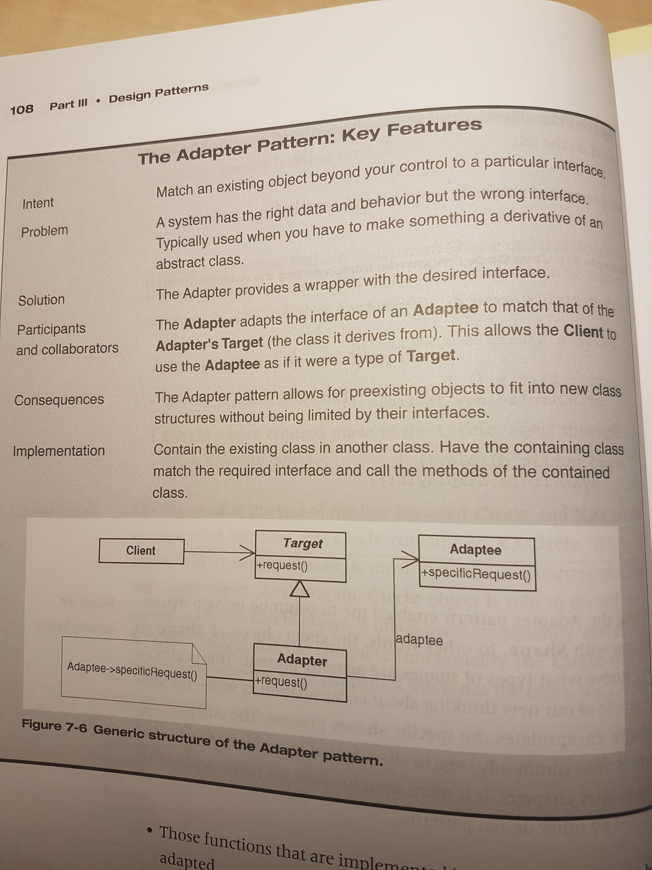

The Adapter provides a wrapper with the desired interface.

The Adapter adapts the interface of an *Adaptee* to match that of the *Adaptee’s Target* (the class it derives from). This allows the *Client* to use the Adaptee as if it were a type of *Target*.

The Adapter pattern allows for preexisting objects to fit into new class structures without being limited by their interfaces.

Two types of Adapter patterns:

- object Adapter pattern - it relies on one object (the adapting object) containing another (the adapted object)

- class Adapter pattern - with multiple inheritance

=> it creates a new class which:

- derives publicly from our abstract class to define its interface

- derives privately from our existing class to access its implementation

=> each wrapped method calls its associated, privately inherited method.

Facade vs Adapter:

- it is possible that a Facade could be used in front of a very complex object (only one) while an Adapter wrapped several small objects that among them implemented the desired function (wrapps severals objects). So, the number of classes hided by these patterns is not part of the actual pattern.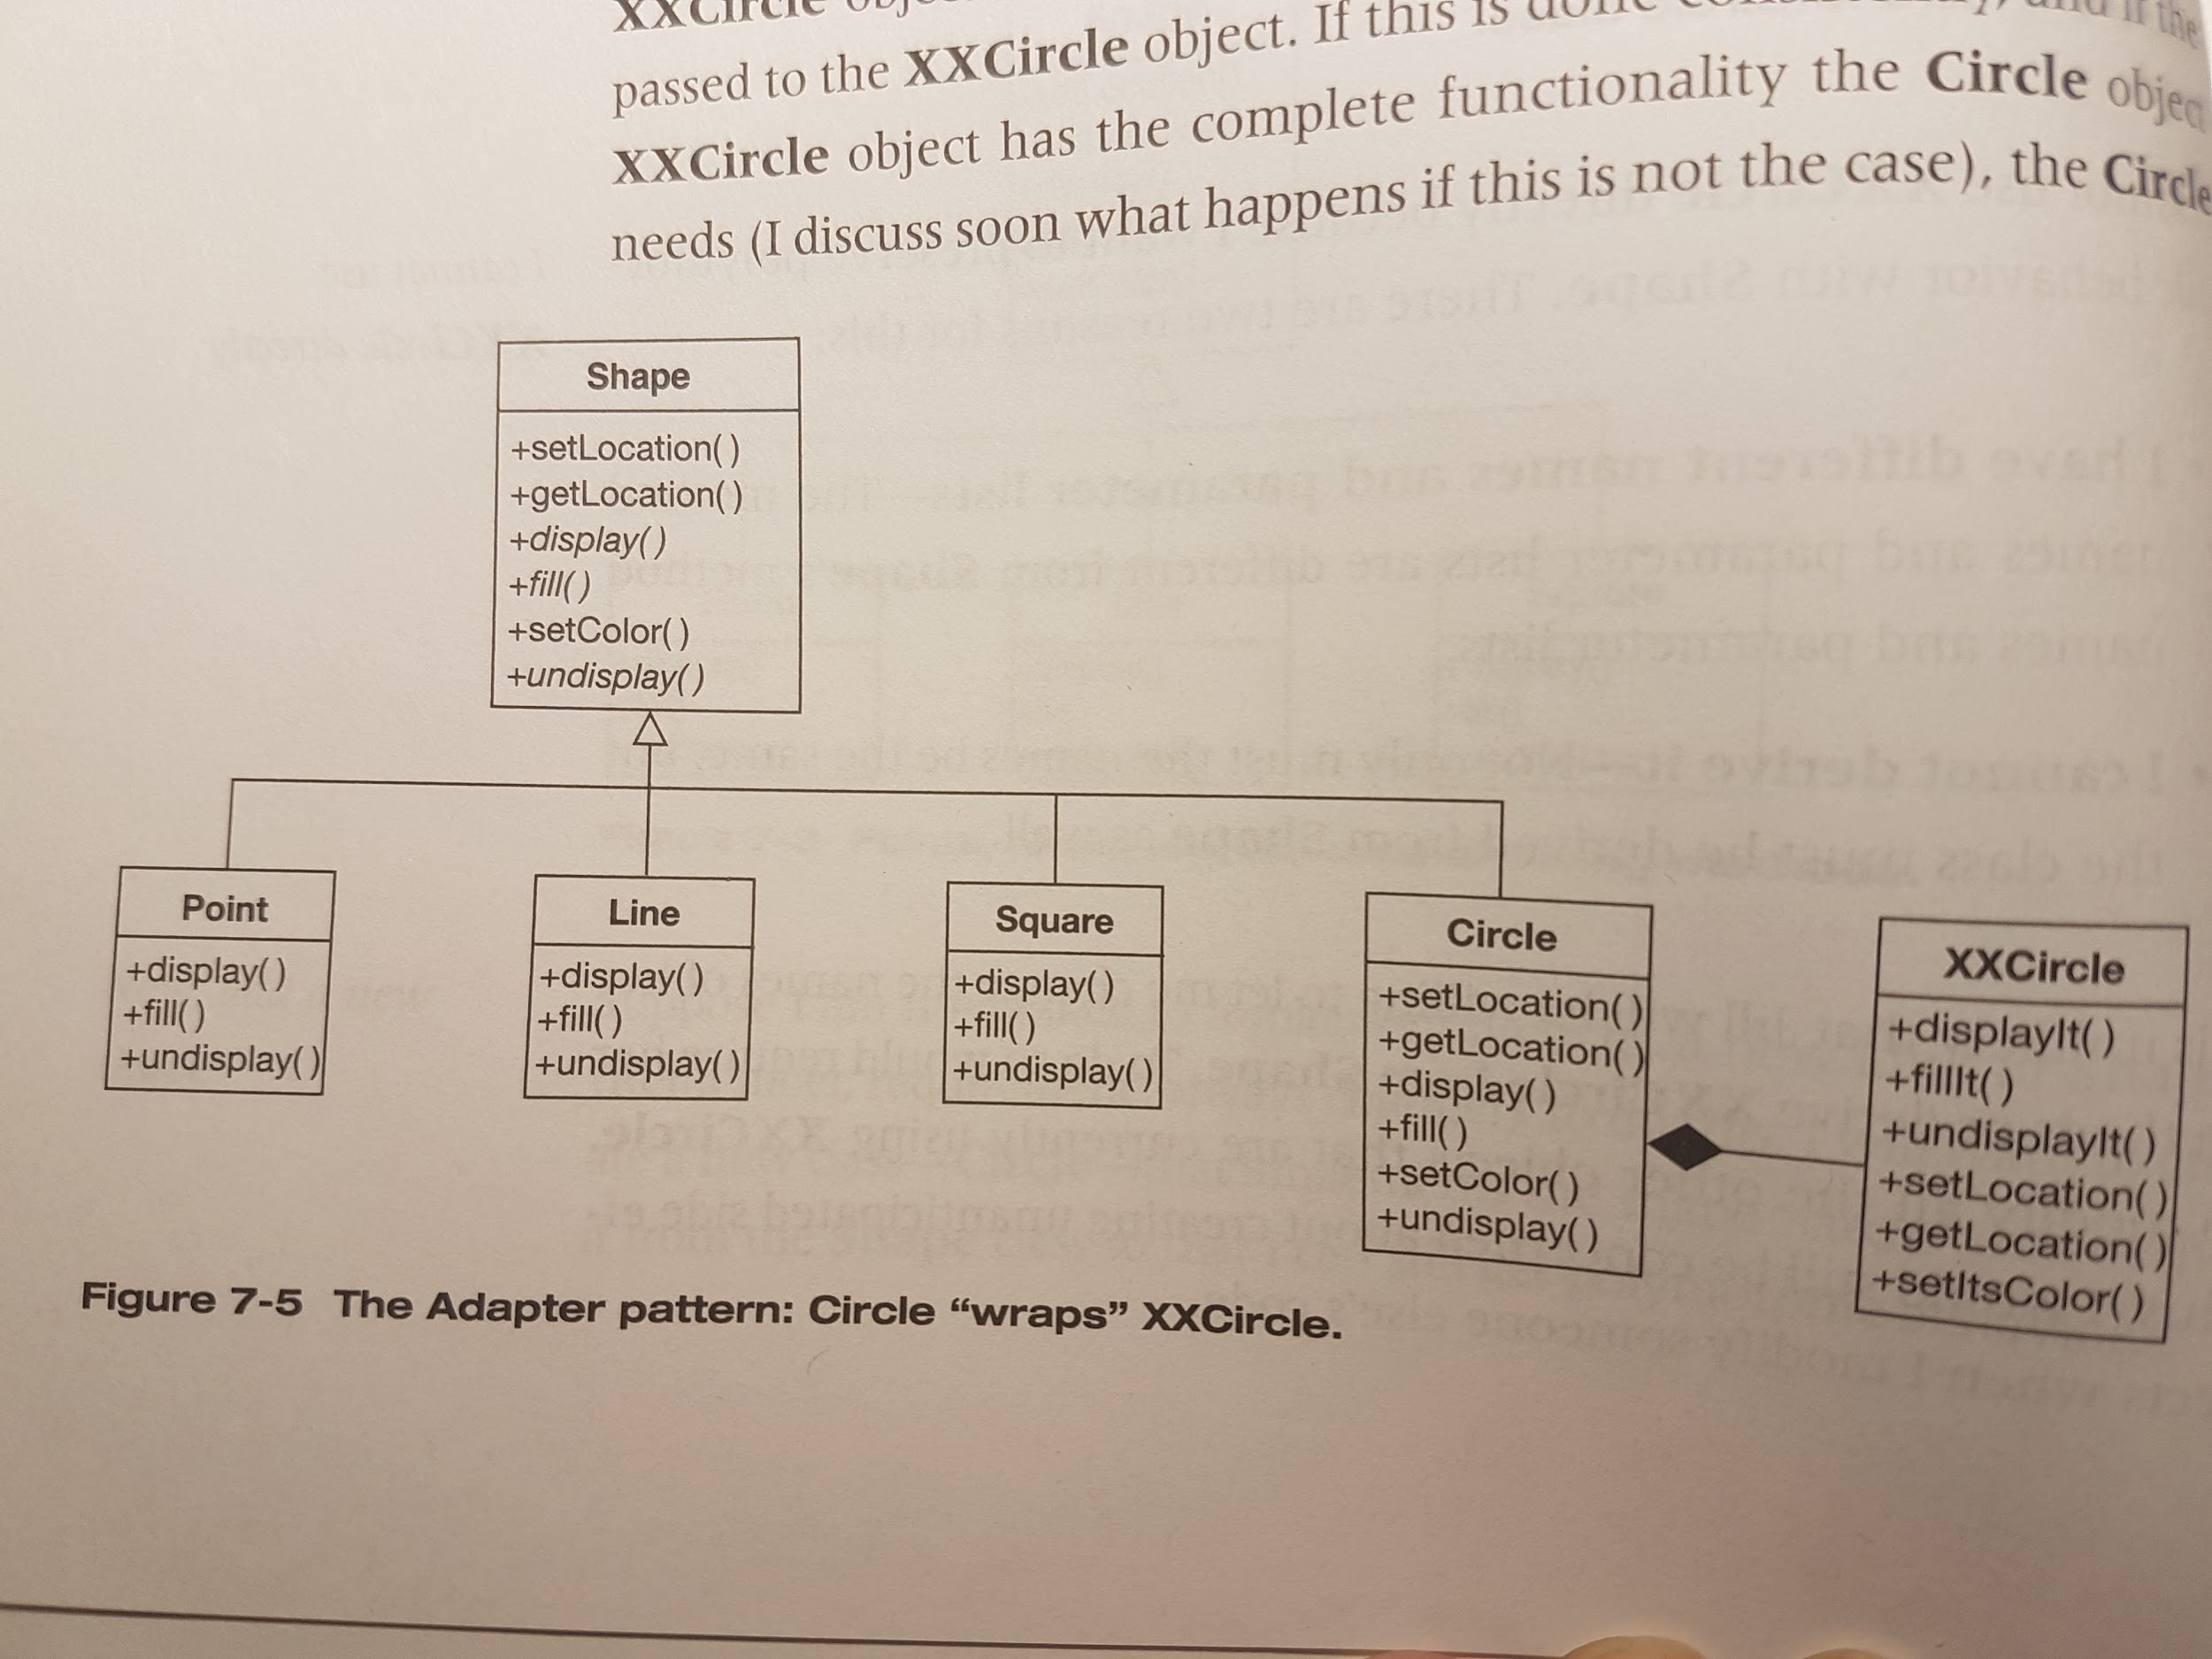

- a Facade pattern **simplifies** an interface whine an Adapter pattern **converts** a preexisting interface interface into another interface.

**Chapter 8 - Expanding our Horizons**

Conceptual perspective: an object is an entity that has responsibilities. These responsibilities define the behavior of the object. This definition helps focus on what the objects are supposed to *do*, not on how the objects are implemented.

A focus on what an object does helps not to worry too early about implementation details. It helps hide those implementation details. And that helps build software that is easier to modify in the future if needed.

The focus should be only on the object’s public interface. There’s no need to know anything about what is going on *inside* the object.

Focusing on motivation rather than on implementation is a recurring theme in design patterns. This is because hiding implementations behind interfaces essentially decouples them from the using objects.

Encapsulation should be thought of as “any kind of hiding”. It can hide data, implementations, derived classes, design details, instantiation rules.

Levels of encapsulation (in the Adapter Pattern chapter for eg.):

- **encapsulation of data** - the data in **Point**, **Line**, **Square** and **Circle** are hidden from everything else

- **encapsulation of methods** - **Circle**’s *setLocation*

- **encapsulation of other objects** - only **Circle** is aware of **XXCircle**

- **encapsulation of type** - clients of Shape don’t see **Point**s, **Line**s, etc. => achieved when there is an abstract class with derivations (or an interface with implementations) that are used polymorphically

The advantage of looking at encapsulation in a broader way is that it gives a better way to split up (decompose) my programs.The encapsulating layers become the interfaces to design to. By encapsulation different kinds of **Shape**s, I can add new ones without changing any of the client programs using them. By encapsulating **XXCircle** behind **Circle**, I can change the implementation in the future if I choose to or need to.

Using inheritance to add specialized classes creates several problems:

- **can cause weak cohesion** -> what happens if there are lots of differences on what makes the specialized class “specialized”? The classes will have to handle more issues.

- **reduces possibility of reuse** -> this code can’t be used for other classes (for eg. Circle will not be able to use something in a Square specialized class)

- **does not scale well with variation** -> partially duplicate the generalized class repeatedly

=> **Find what varies and encapsulate it**.

Identify where things vary (“*commonality analysis*” - the search for common elements that help to understand how family members are the same) and then identify how they vary (“*variability analysis*” - it reveals how family members vary. It only makes sense within a given commonality).

“Commonality analysis seeks structure that is unlikely to change over time, while variability analysis captures structure that is likely to change. Variability analysis makes sense only in terms of the context defined by the associated commonality analysis… From an architectural perspective, commonality analysis gives the architecture its longevity; variability analysis drives its fitness for use.” (Coplien, ‘Multi-Paradigm Design for C++’)

The common concepts in the domain = the abstract classes

The variations found by variability analysis will be implemented by the concrete classes (classes derived from the abstract class with specific implementations)

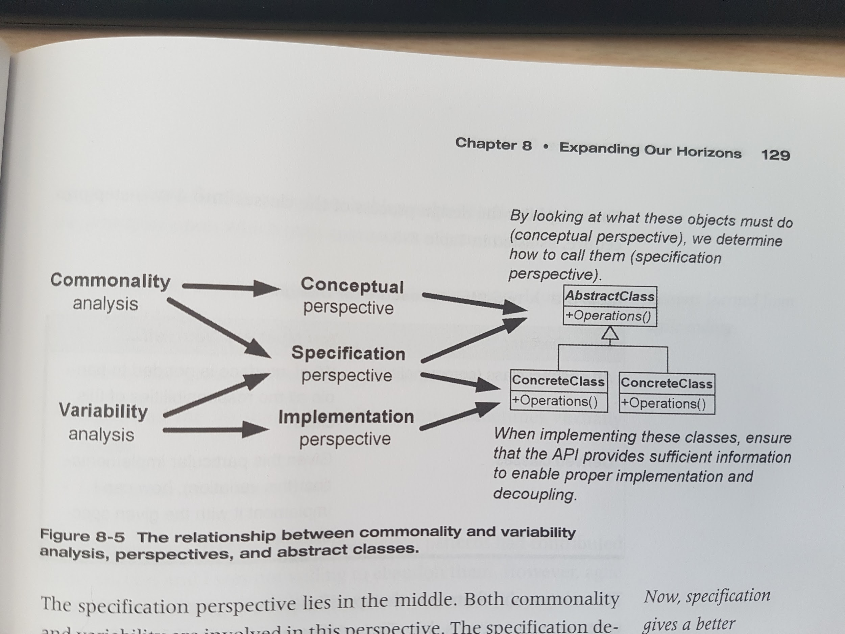

Both agile and patterns approaches require the same qualities in the code. Agile requires code that is changeable, patterns result in code that is flexible. Other qualities agile practices focus on:

- no redundancy (“One rule, one place”) => *a powerful relationship exists between redundancy & coupling.*

- Beck, ‘Extreme Programming Explained: Embrace Change’: “Once and Only Once rule”

=> The system (code and tests) must communicate everything yo9u want to communicate

=> The system must contain no duplicate code

- it typically requires using several small methods for a single rule => minimal extra cost

- if redundant code is present and it becomes necessary to change one of the sections of code, it is very likely the other section will need to be changed as well => the 2 sections of redundant code are also coupled to each other

- readability => it is related to strong cohesion

- related to “program by intention” (Jeffries, ‘Extreme Programming Installed’) => when you write code give it an “intention-revealing name” (label or name that clearly and succinctly communicates what the function is responsible for doing)

Martin Fowler - ‘Refactoring: Improving the Design of Existing Code’

- testability

- testability is strongly correlated to the other practices:

=> **cohesive** code is easier to test because the code is only about one thing

=> **loosely coupled** code is easier to test than tightly coupled code because there are minimal interactions to worry about

=> **redundant** code is not harder to test in itself, but requires more tests to cover the redundancy -> the testability of the entire system degrades when you have more redundancy

=> **readable** code is easier to test because method names & parameters describe precisely what each is supposed to do

=> **encapsulated** code is easier to test because it will have little if any coupling to other code

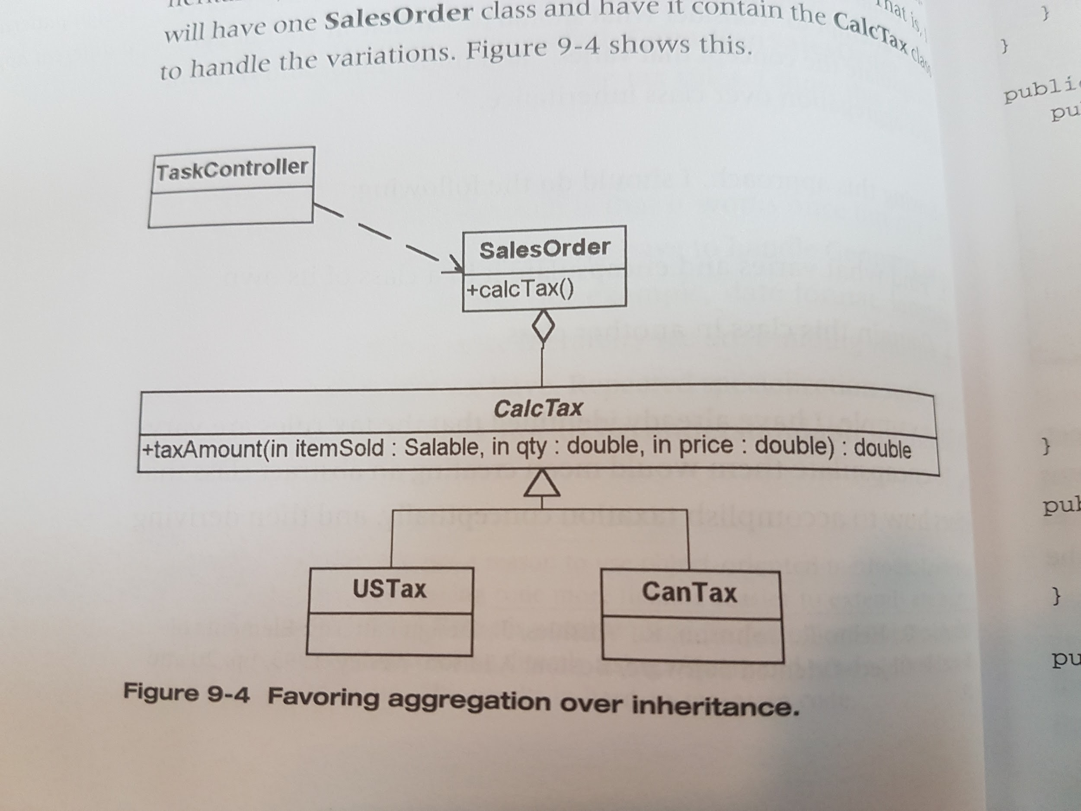

**Chapter 9 -** [**The Strategy Pattern**](https://www.tutorialspoint.com/design_pattern/strategy_pattern.htm) **(Behavior Pattern)**

[**Wiki**](https://en.wikipedia.org/wiki/Strategy_pattern)

Instead of considering what might *force* a change to a design, consider what you want to be *able* to change without redesign. => the focus is on *encapsulating the concept that varies*.

1. Find what varies and encapsulate it in a class of its own.

2. Contain this class in another class.

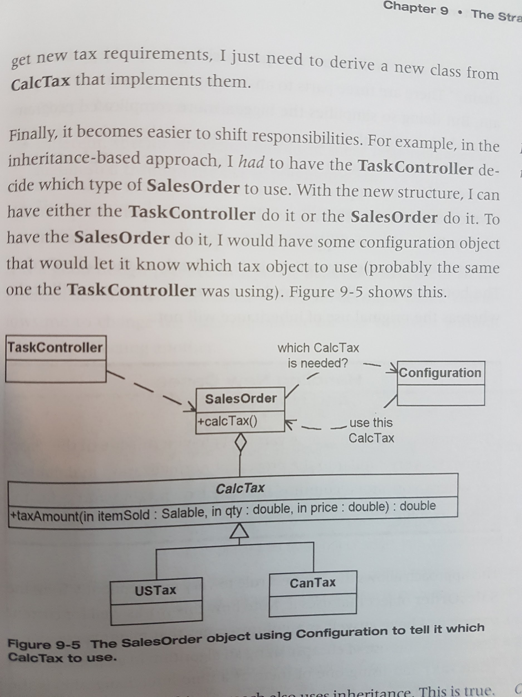

Advantages of using aggregation for taxes:

- cohesion improved -> sales tax is handled in its own class

- adding a new tax requirement means adding a new derived class from **CalcTax** that implements the new tax rules

- easier to shift responsibility

An object aggregation approach is used here (with this pattern).

**SalesOrder** *contains* a reference to the object that handles the function that is varying - tax. From the perspective of the **SalesOrder** (the class I’m trying to extend), I am favoring aggregation over inheritance. How the contained class handles its variations is no concern of the **SalesOrder**.

What this pattern does:

- simplifies the bigger, more complicated program

- this approach captures each of the variables in its own class hierarchy -> it allows them to be independently extended

- other pieces of the system can use (or test) these smaller operations independently of the **SalesOrder**

=> this approaches scales

The Strategy pattern’s intent according to GoF: “Define a family of algorithms, encapsulate each one, and make them interchangeable. Strategy lets the algorithm vary independently from clients that use it.”

The Strategy pattern is based on a few principles:

- objects have responsibilities

- different, specific implementations of these responsibilities are manifested through the use of polymorphism

- there is a need to manage several different implementations of what is, conceptually, the same algorithm

Intent: Enables you to use different business rules or algorithms depending on the context in which they occur.

Problem: The selection of an algorithm that needs to be applied depends on the client making the request or the data being acted on. If you just have a rule in place that does not change, you do not need a Strategy pattern.

The selection of the algorithm will be made based on the context.

You must invoke all algorithms in the same way (they must have the same interface).

**When I am doing analysis and I hear about applying different business rules at different times, I consider the possibility of a Strategy pattern handling this variation for me.**

- there is coupling between context and strategies (the business rules are outside the class that are using them, the Context, and the information needed by the strategies must either be passed to them or obtained in some other manner).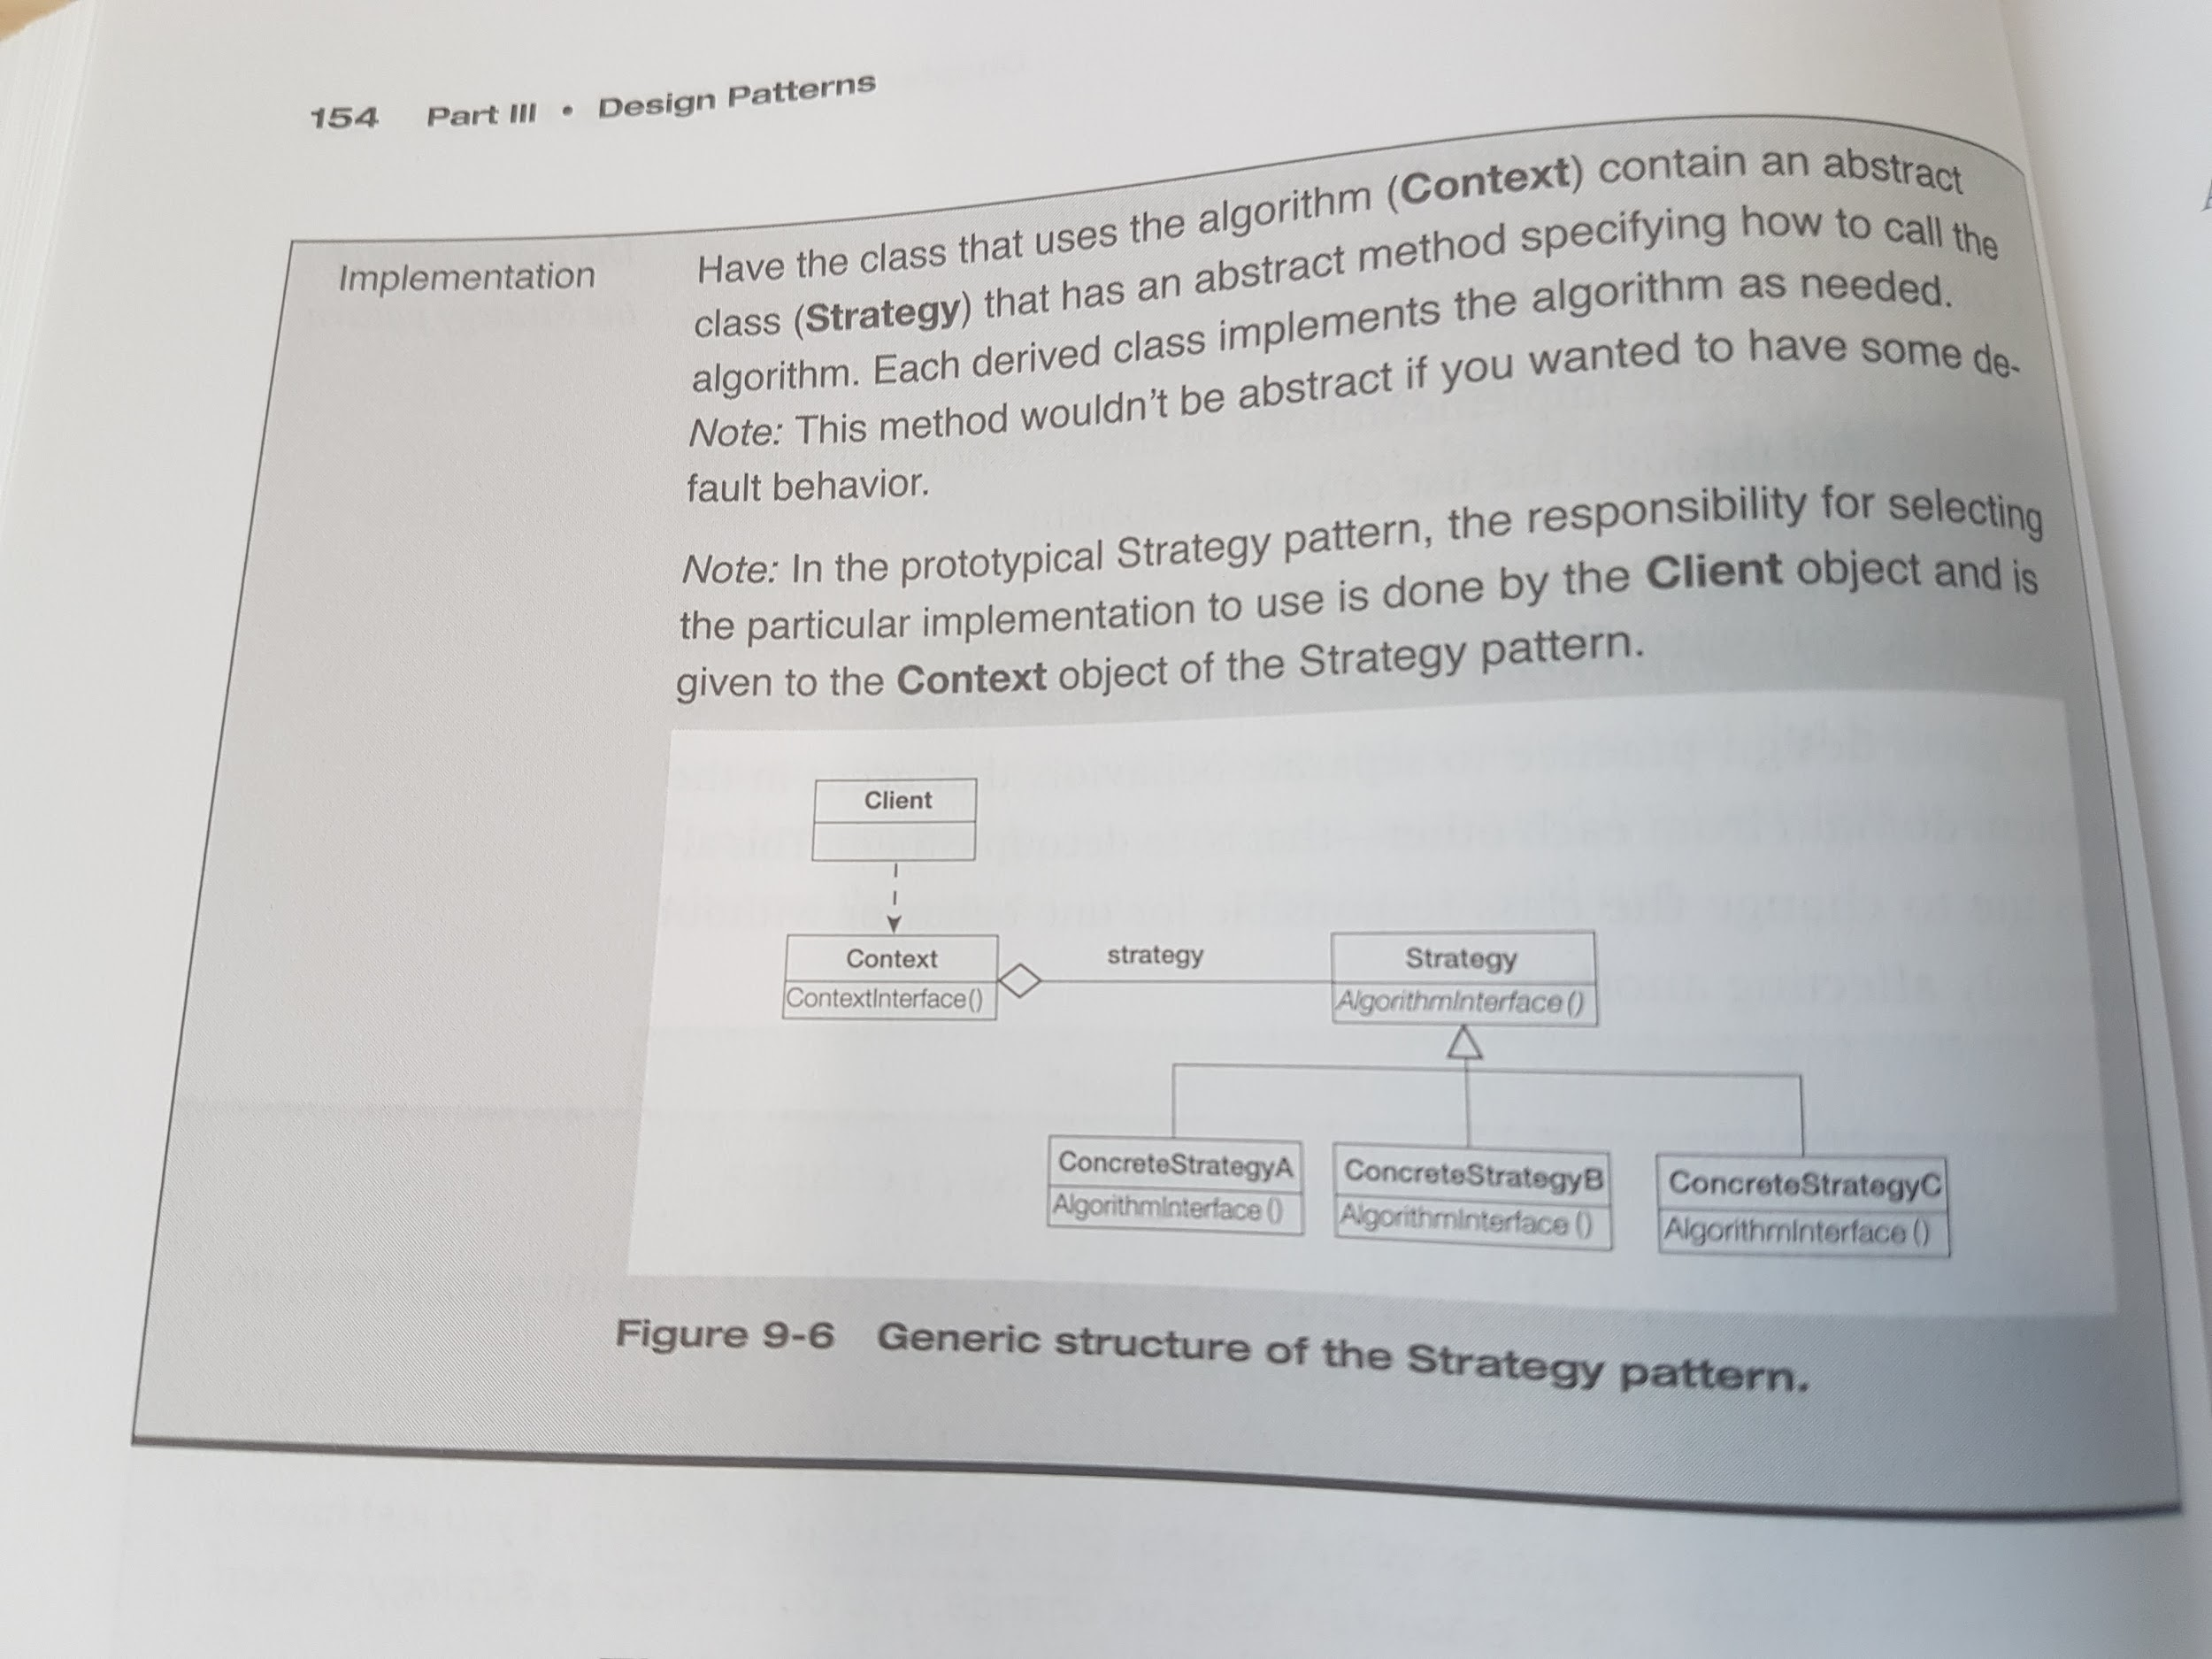

- lower cost of unit tests, because each algorithm is in its own class and can be tested through its interface alone.

**A variation of the Strategy pattern will be to assign this strategy object to the context in the Strategy pattern in the context’s constructor.** Eg.: same tax strategy for any one particular **SalesOrder** object. The context, the SalesOrder, doesn’t know what particular type of strategy object it has, so the power of the pattern is still maintained. For this to be implemented, the particular strategy object needs to be known at the time the context object is constructed.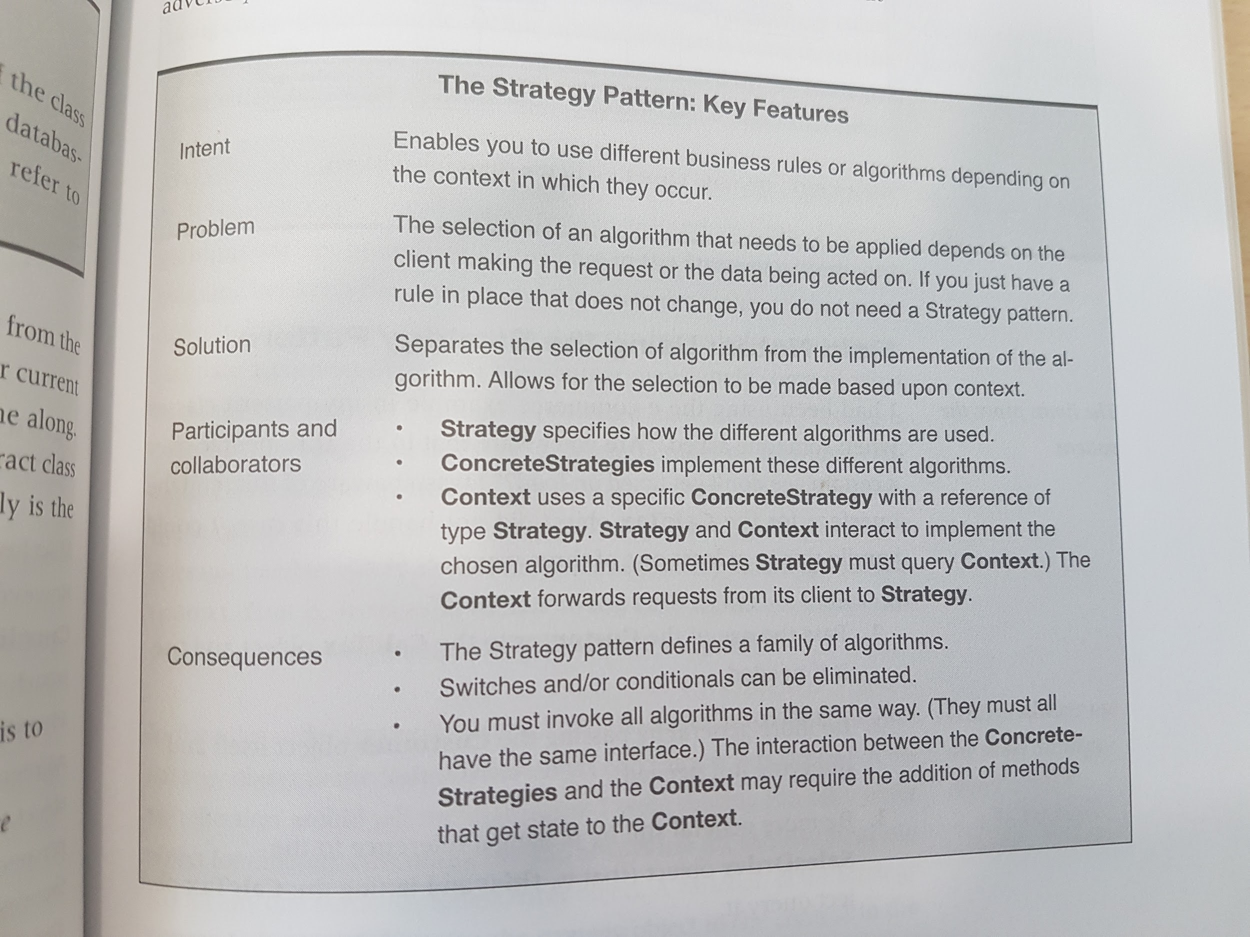

Inner classes can be used in the abstract class class to contain all the concrete strategies (if there is control over all the strategies and other programmers don’t need to implement their own algorithms).

**Chapter 10 -** [**The Bridge Pattern**](https://www.tutorialspoint.com/design_pattern/bridge_pattern.htm) **(Structural Pattern)**

[**Wiki**](https://en.wikipedia.org/wiki/Bridge_pattern)

Intent: Decouple abstraction from implementation (so that the 2 can vary independently)

*Implementation* here means the objects that the abstract class and its derivations use to implement themselves (not the derivations of the abstract class, which are called concrete classes).

The pattern goes against a common tendency to handle special cases with inheritance.

Situations encountered for this pattern:

- variations in abstractions of a concept

- variations in how these concepts are implemented

Example:

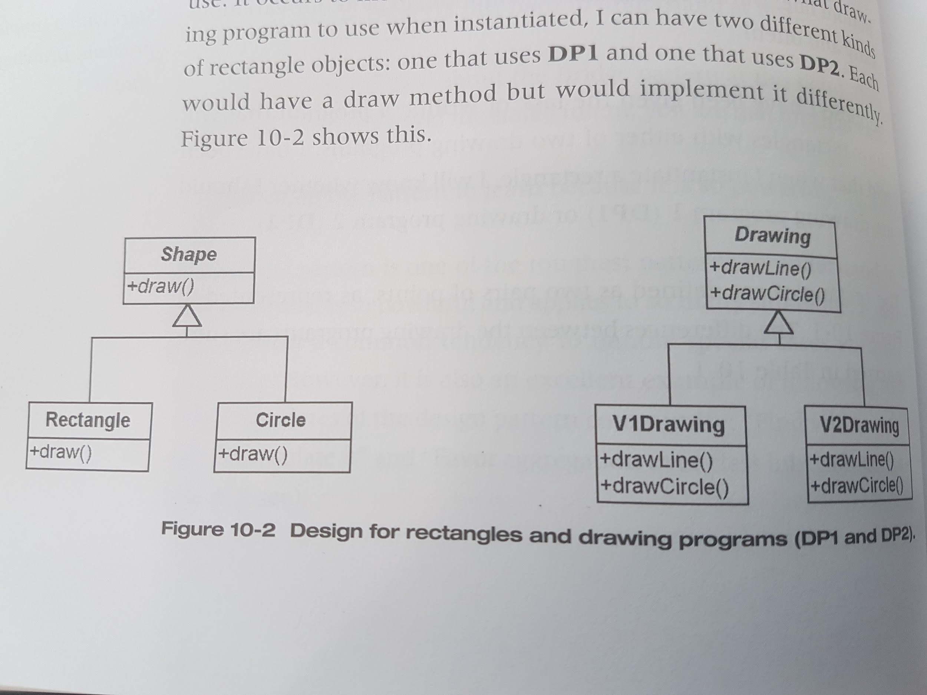

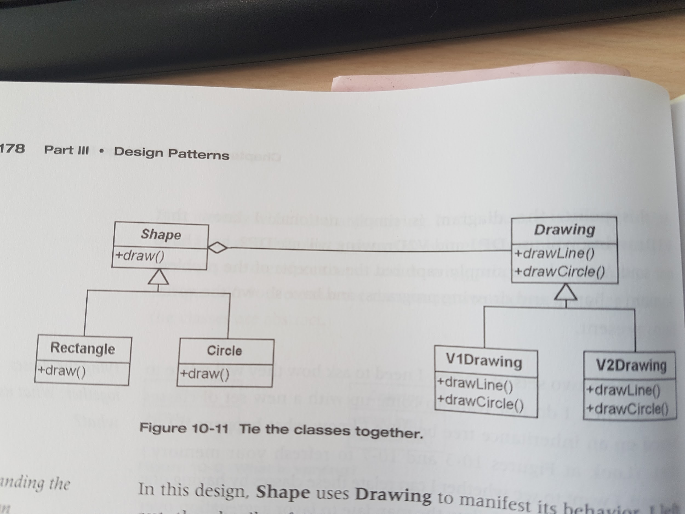

Taking an approach that looks for where you can apply patterns tells you *what to do* but not *when to use it* or *why to do it*.

An object should only be responsible for itself.Peter Coad, **Java Design**

When 2 or more patterns are tightly integrated, the result is called a **compound design pattern**.

Martin Fowler - Refactoring: Improving the Design of Existing Code

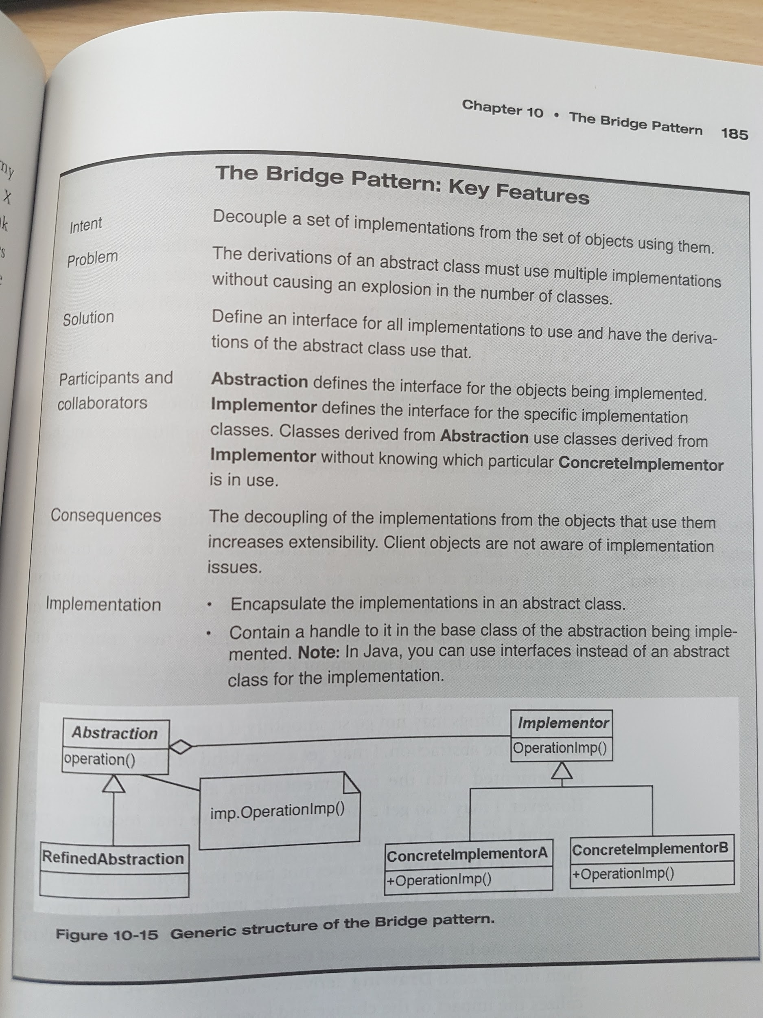

**Chapter 11 -** [**The Abstract Factory Pattern**](https://www.tutorialspoint.com/design_pattern/abstract_factory_pattern.htm) **(Creational Pattern)**

[**Wiki**](https://en.wikipedia.org/wiki/Abstract_factory_pattern)

Intent: Coordinate the instantiation of objects

GoF: => to “provide an interface for creating families of related or dependent objects without specifying their concrete classes”.

Often a switch indicates the need for polymorphic behavior or the presence of misplaced responsibilities. Consider instead a more general solution such an abstraction or giving the responsibility to other objects.

In this pattern:

- the client object just knows who to ask for the objects it needs and how to use them

- the Abstract Factory class specifies which objects can be instantiated by defining a method for each of these different types of objects. Typically, an Abstract Factory object will have a method for each type of object that must be instantiated

- the concrete factories specify which objects are to be instantiated

Strengthening cohesion makes the main code more readable, encapsulates the rules for choosing objects, and encourages the use of concrete objects in a more abstract fashion.

The pattern is called the “Abstract Pattern” because the things it is intended to build are *themselves* defined by abstractions. How you choose to implement that factory variations is not specific to the pattern.

The Abstract Factory pattern affords us a new kind of decomposition - decomposition by responsibility. It decomposes our problem into who is using our particular objects? (ApControl) and who is deciding upon which particular objects to use (AbstractFactory).

Using the Abstract Factory is indicated when the problem domain has different families of objects present and each family is used under different circumstances.

You may define families according to any number of reasons:

- different operating systems - when writing cross-platform applications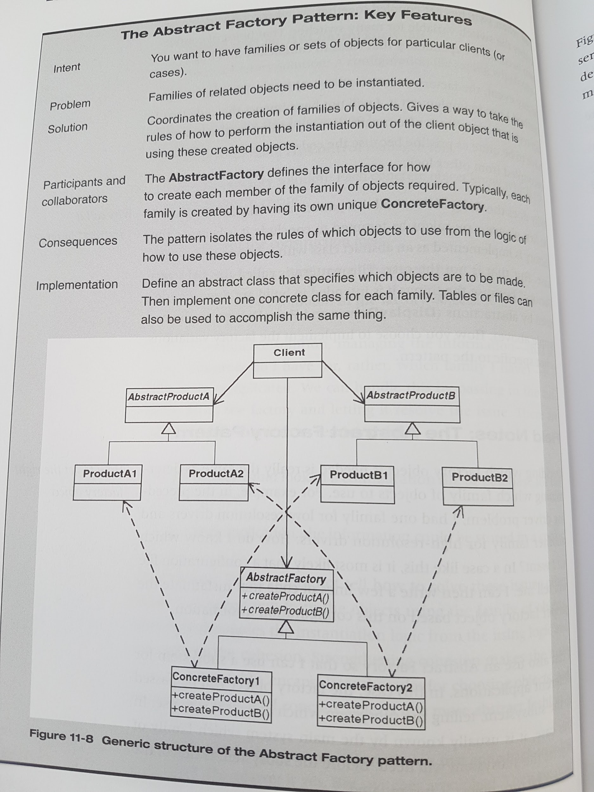

- different performance guidelines

- different versions of apps

- different traits for users of the app

- different sets of locale-dependent resources (eg., dialogs, date formats, etc)

Variation: configuration files:

- you want to have a configuration file file that specifies which objects to use. You can use a switch based on the information in the configuration file that instantiates the correct object

- each family can have a record in the database that contains information about which objects it is to use. Each column/field indicates which specific class type to use for each make method in the Abstract Factory.

Variation: using the Class class in Java.

- have fields represent the class name to use

- you don’t need to store the full class name as long as you have a well-defined convention.

Rules regarding how to perform the instantiation out of the client object that is using these created objects:

- first identify the rules for instantiation and define an abstract class with an interface that has a method for each object that needs to be instantiated

- then implement concrete classes from this class for each family

- the client object uses this factory object to create the server objects that it needs

**Part IV - Putting it all together: Thinking in patterns**

**Chapter 12 - How do Experts Design?**

In short, each part is given its specific form by its existence in the context of the larger whole.

This is a differentiating process. It views design as a sequence of acts of complexification: structure is injected into the whole by operating on the whole and crinkling it, not by adding little parts to one another. In the process of differentiation, the while gives birth to its parts: The form of the whole, and its parts, come into being simultaneously. The image of the differentiating process is the growth of an embryo.

Each pattern is an operator that differentiates space: it creates distinctions where no distinction was before.

Christopher Alexander asserts that design should start with a simple statement of the problem, then make it more detailed (complex) by injecting information into the statement. This information takes the form of a pattern. To Alexander, a pattern defines relationships between the entities in his problem domain.

The rules of a good designer:

- one at a time - patterns should be applied one at a time in sequence

- context first - apply those patterns first than create the context for the other patterns

Identify the patterns that create the context for the other patterns. These should be your starting point.

Design is normally thought of as a process of synthesis, a process of putting things together. In software, a common approach is to look immediately for objects and classes and components and then think about how they should fit together.

In The Timeless Way of Building, Christopher Alexander describes a better approach, based on approach:

- start out with a conceptual understanding of the whole in order to understand what needs to be accomplished

- identify the patterns that are present in the whole

- start with those patterns that create the context for the others

- work inward from the context: apply a pattern, identify new patterns, and repeat

- redefine the design and implement within the context created by applying these patterns one at a time.

**Chapter 13 - Solving the CAD/CAM Problem with Patterns**

*Rule*: Consider what you need to have in your system before you concern yourself with how to create it.

Patterns that are motivated by using objects create the context for patterns that are about instantiating objects => we define our factories after we decided what out objects are.

**Joshua Bloch - Effective Java Programming**

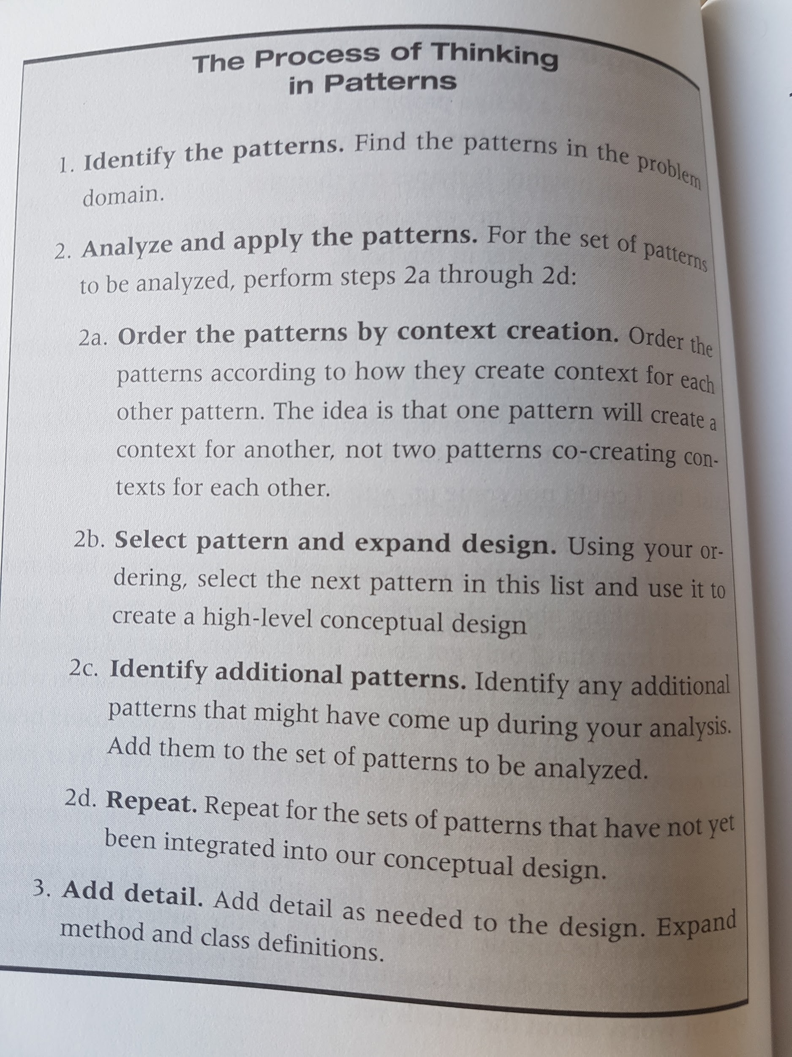

**Part V - Toward a New Paradigm of Design**

**Chapter 14 - The Principles and Strategies of Design Patterns**

The Open-Closed Principle

**Bertrand Meyer proposed the open-closed principle (OCP) - Object-Oriented Software Construction**

=> design your code so that you extend its capabilities without changing it

=> design our software so new functionality can be added in separate, distinct modules, with the integration cost being minimal

Dependency Injection - Depend on abstraction

=> the coupling between the using objects and the used objects is done at a conceptual level, not at the implementation level (“design to interfaces”)

Designing to context, using CVA (commonality and variability analysis) helps me decide how generalized I want to make the implementations based on the extra cost of extra generalization.

**Barbara Liskov - Data Abstraction and Hierarchy**

=> the subtypes should not afd new public methods to the base type’s public interface

=> the base type must be a complete specification of the concept being modeled.

**Alan Shalloway - “Can Patterns Be Harmful?”**

Don’t ask “Which of these implementations is better?” but “Under what circumstances would this alternative br better than the other alternative?” and then ask “Which of these circumstances is more likely my problem domain?”

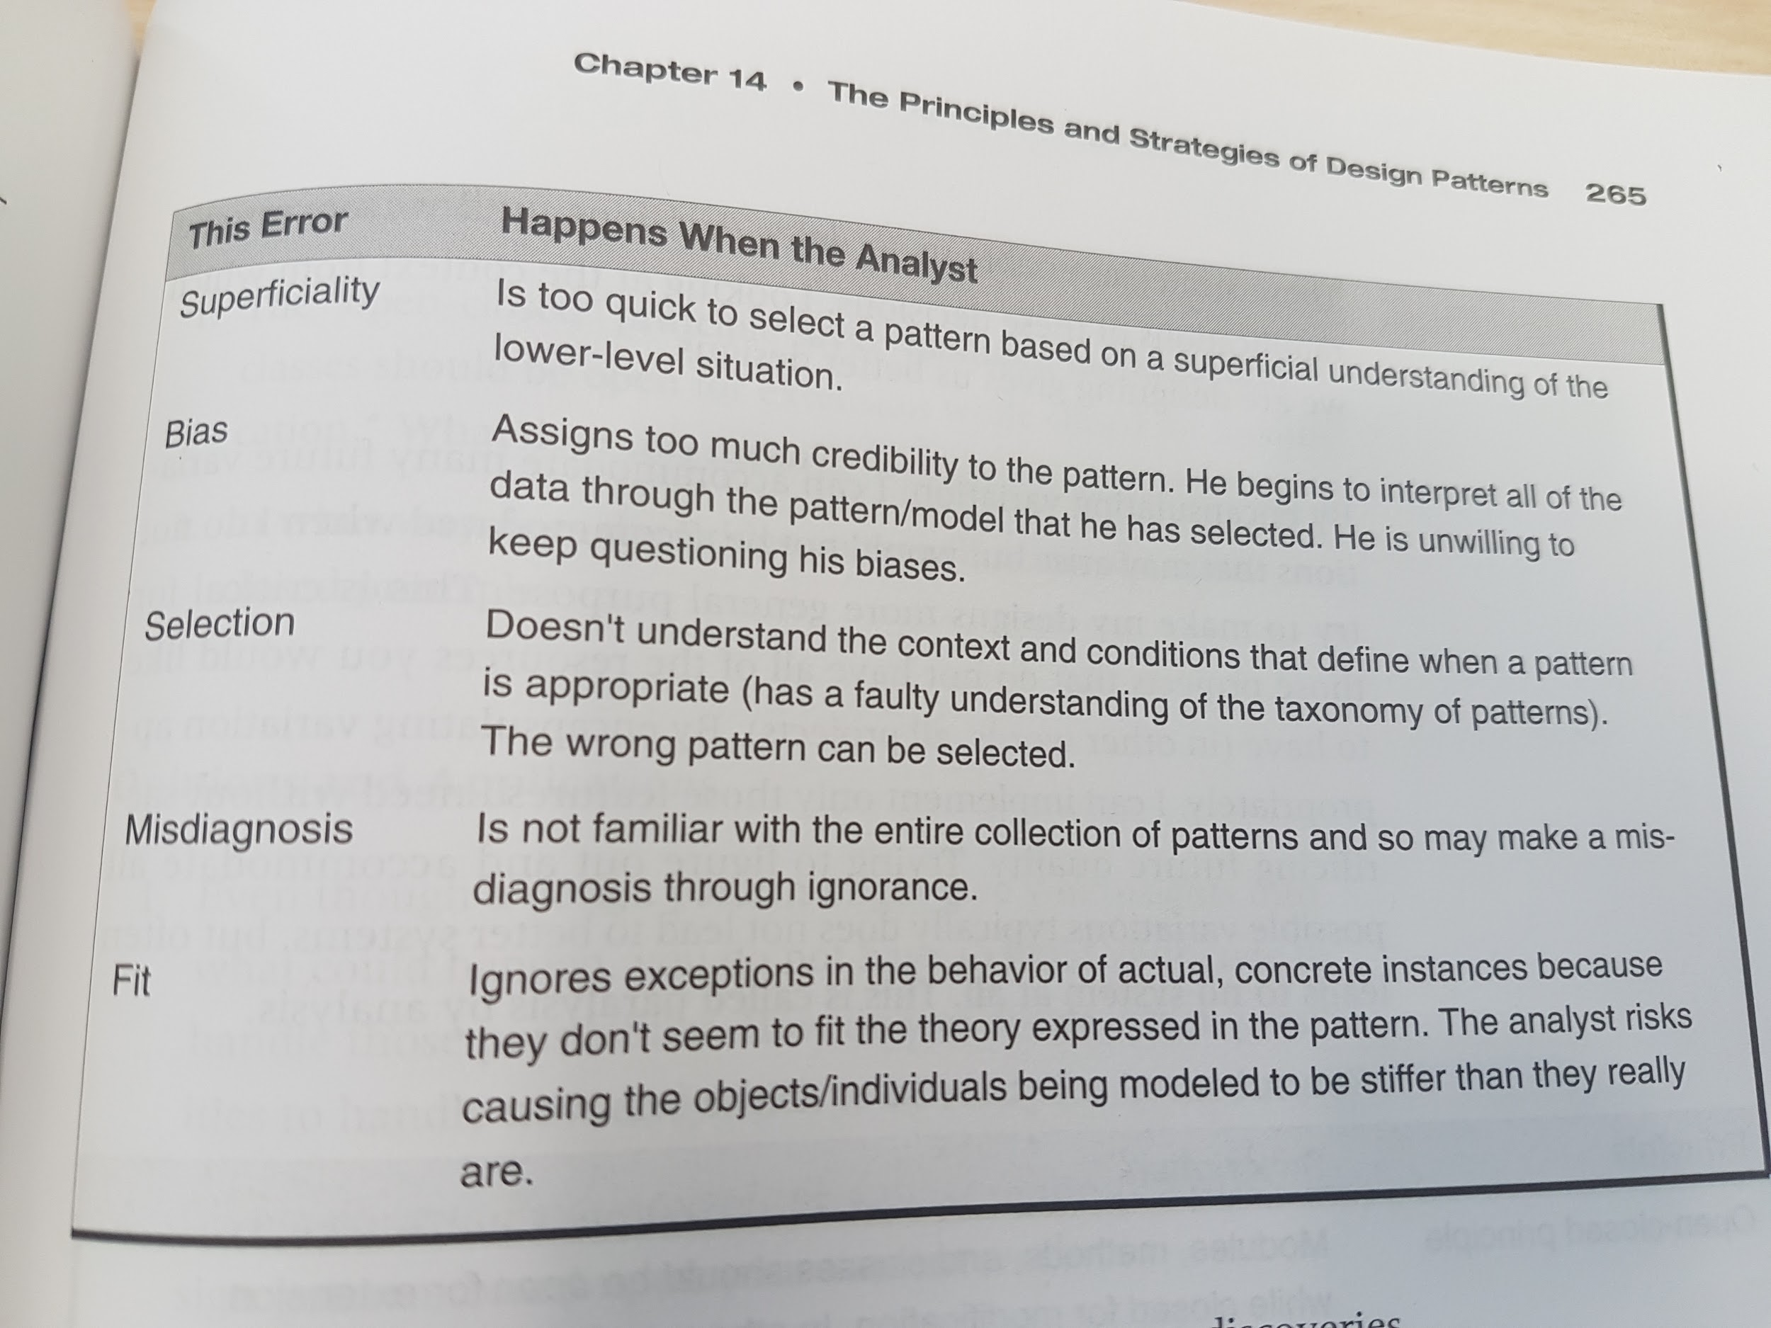

Meta-level patterns and models are not truth. They are abstractions of truth. They are distillations of experience and lessons learned. They must be instantiated with real-world data.

Patterns are discoveries, not inventions. The pattern that is “right” for your problem is IN the problem, not something to be imposed upon it. The specific way a pattern should be implemented should be dictated by the nature of the problem, its constraints, requirements, etc., not based on an implementation you happened to have run across in a patterns book.

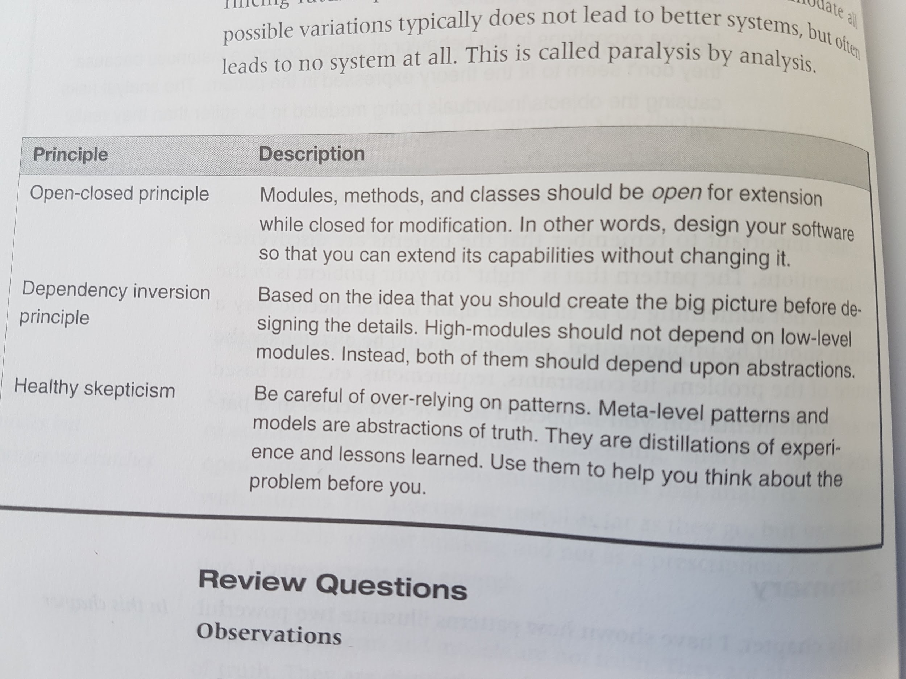

**Chapter 15 - Commonality and Variability Analysis (CVA)**

- identify variations in your system using CVA

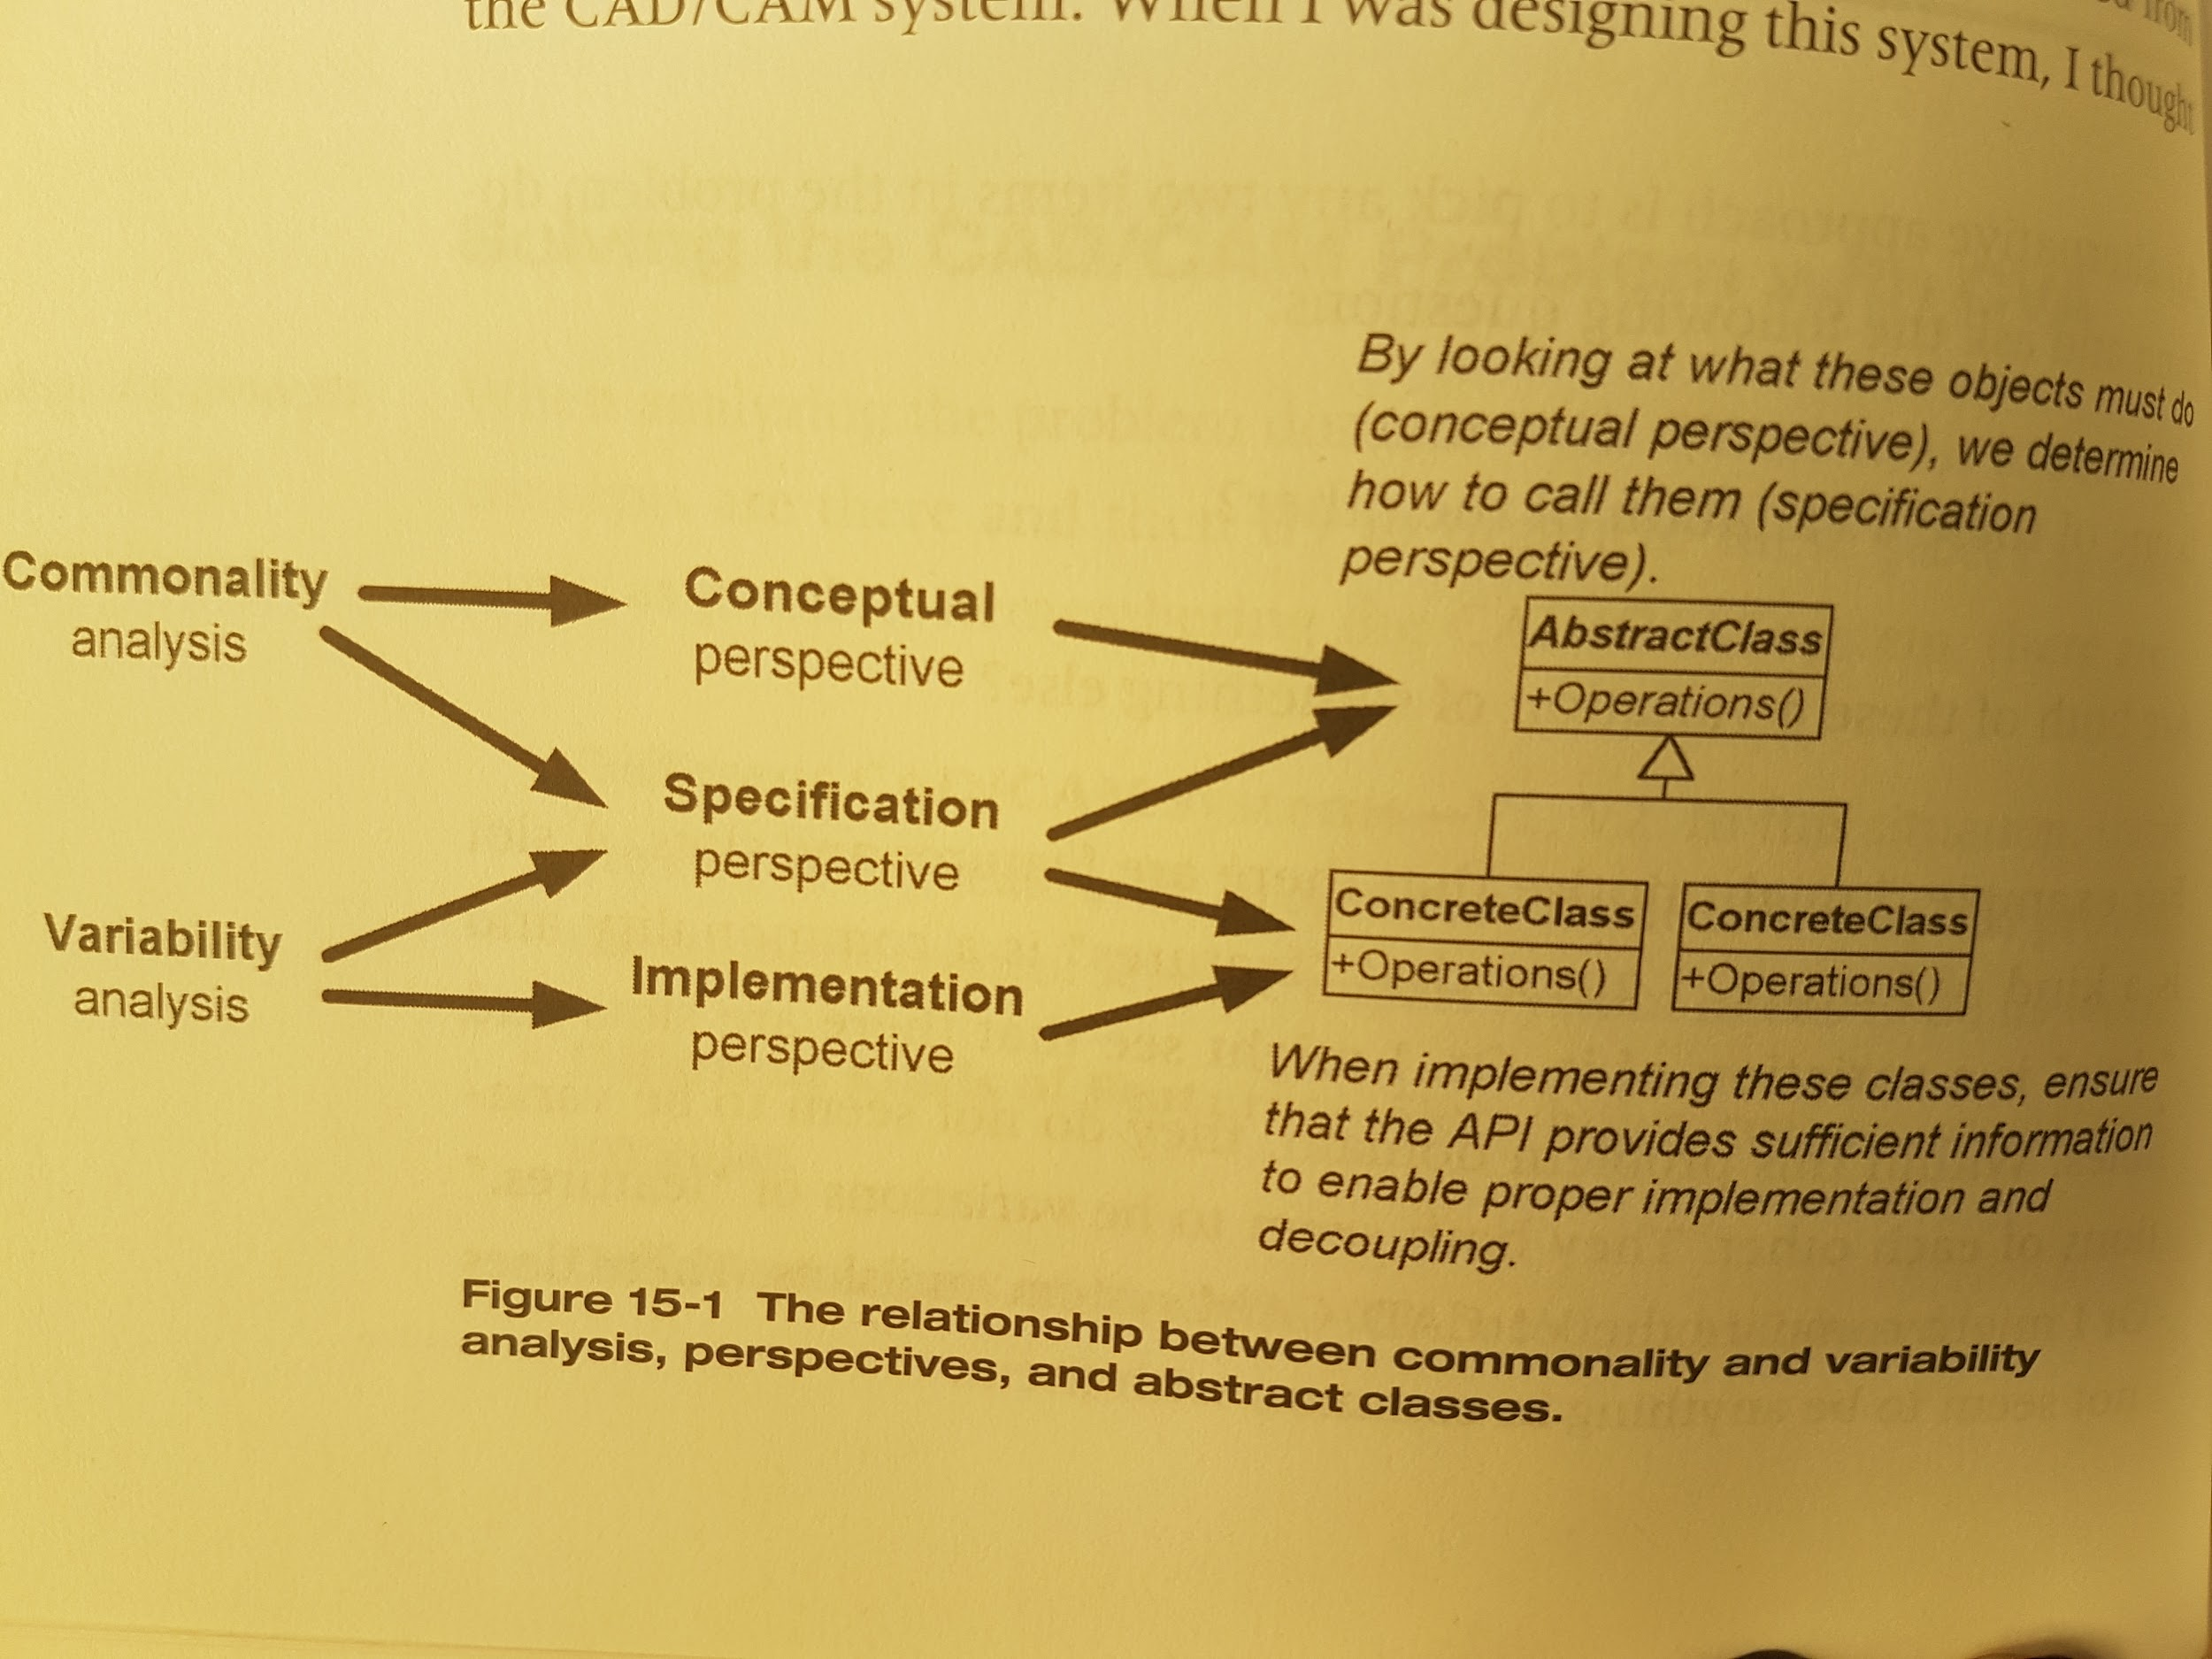

CVA approach:

- identify commonalities first

- create abstractions from these

- identify derivations with the variations of the commonalities

- see how the commonalities relate to each other

**Chapter 16 - The Analysis Matrix**

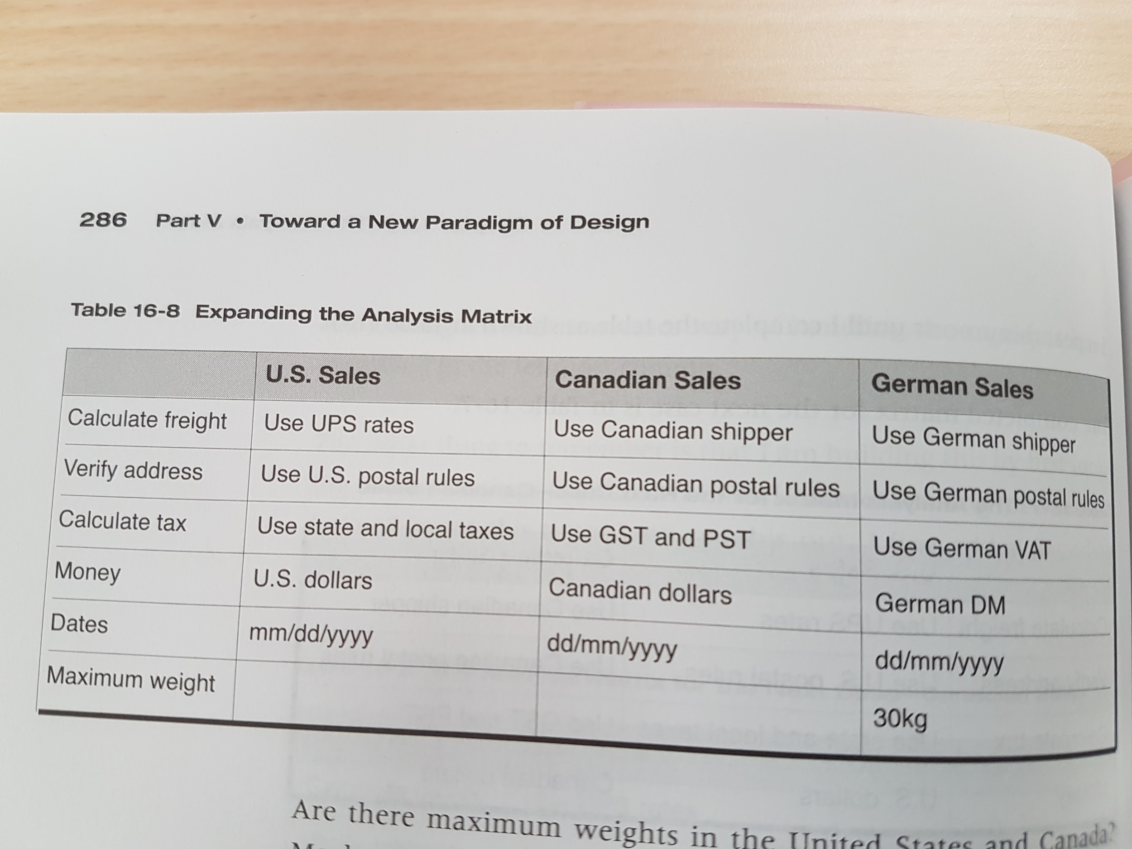

Clients often use the term *always* when they mean *usually*.

Clients often use the term *never* when they mean *seldom*.

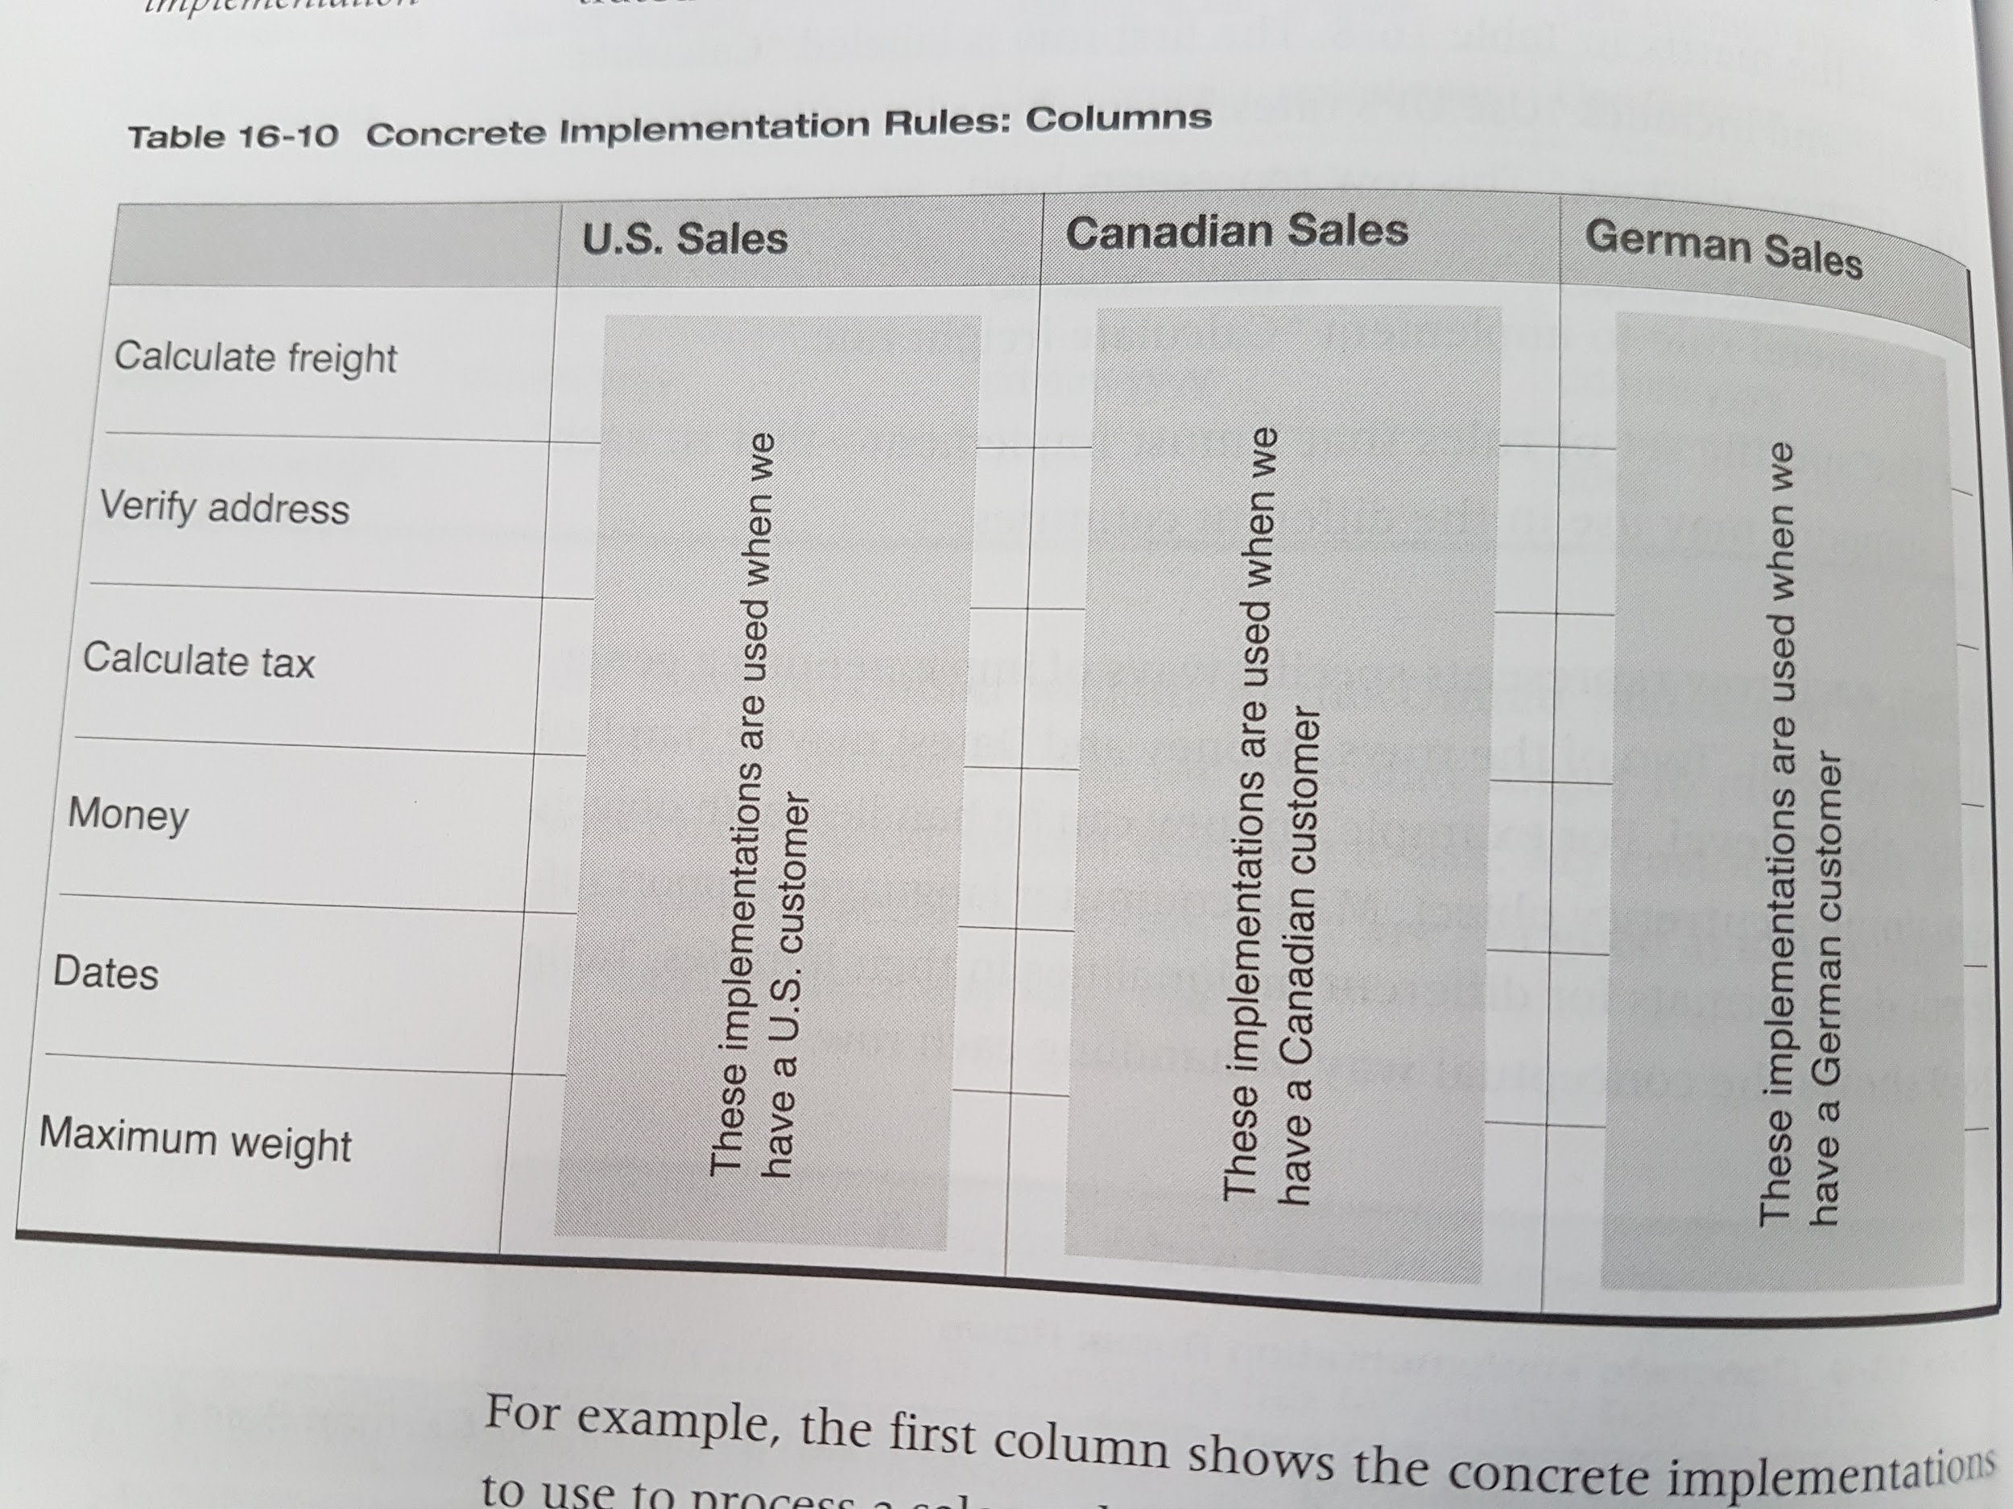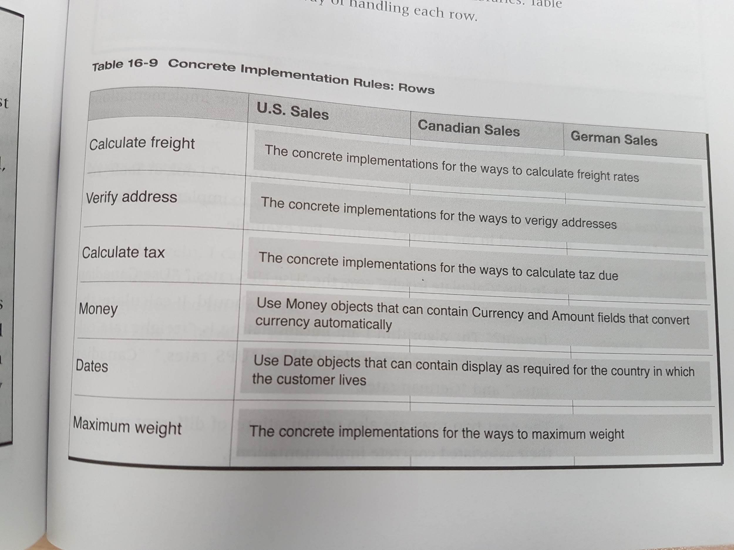

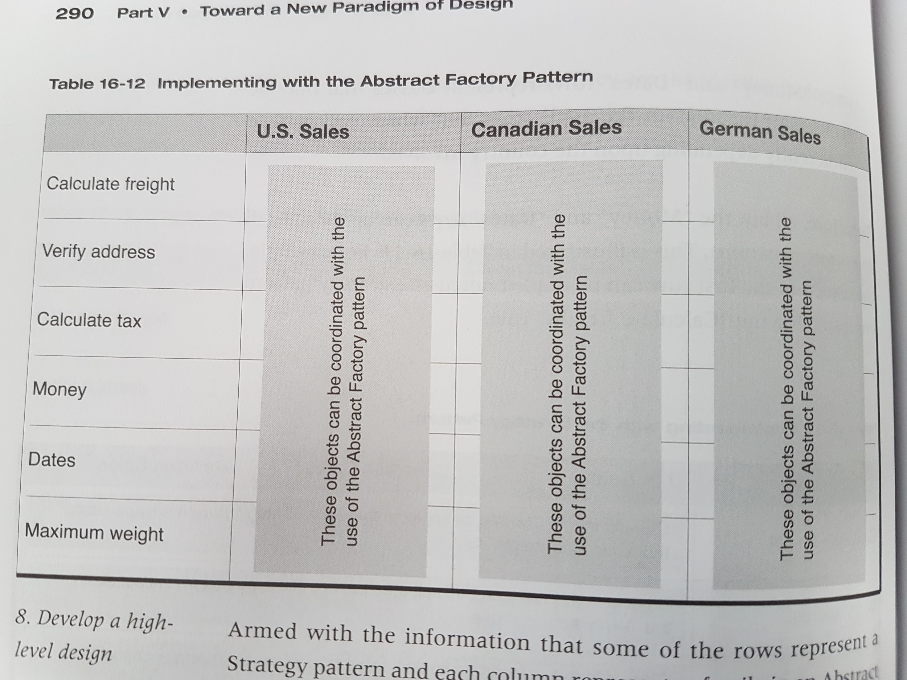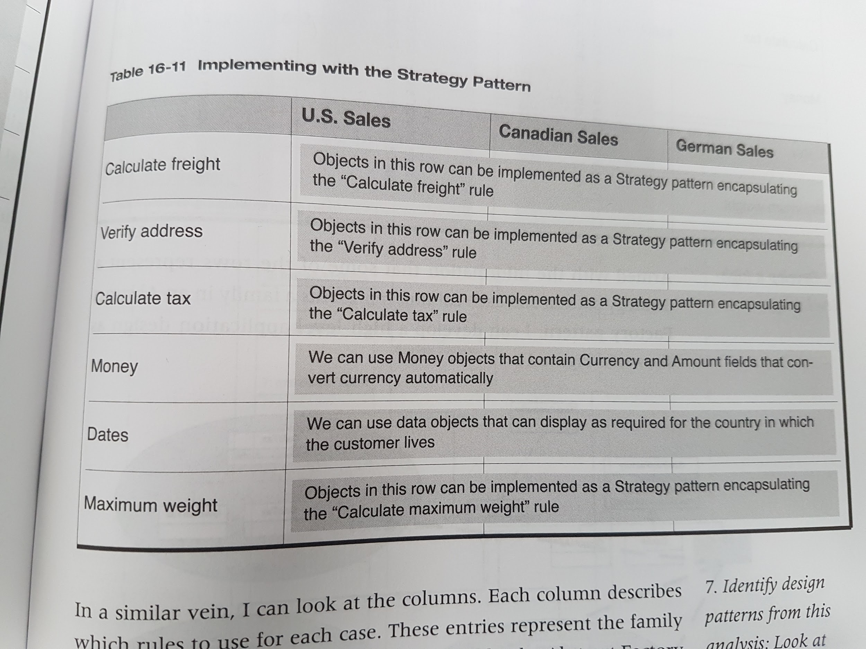

**Chapter 17 - The Decorator Pattern**

Instead of controlling added functionality by having a control method, the Decorator pattern says to control it by chaining together the functions desired in the correct order needed.

The Decorator pattern separates the dynamic building of the chain of functionality from the client that uses it. It also separates the building of the chain from the chain components. This allows for flexible use of these components.

GoF => Attach additional responsibilities to an object dynamically. Decorators provide a flexible alternative to subclassing for extending functionality

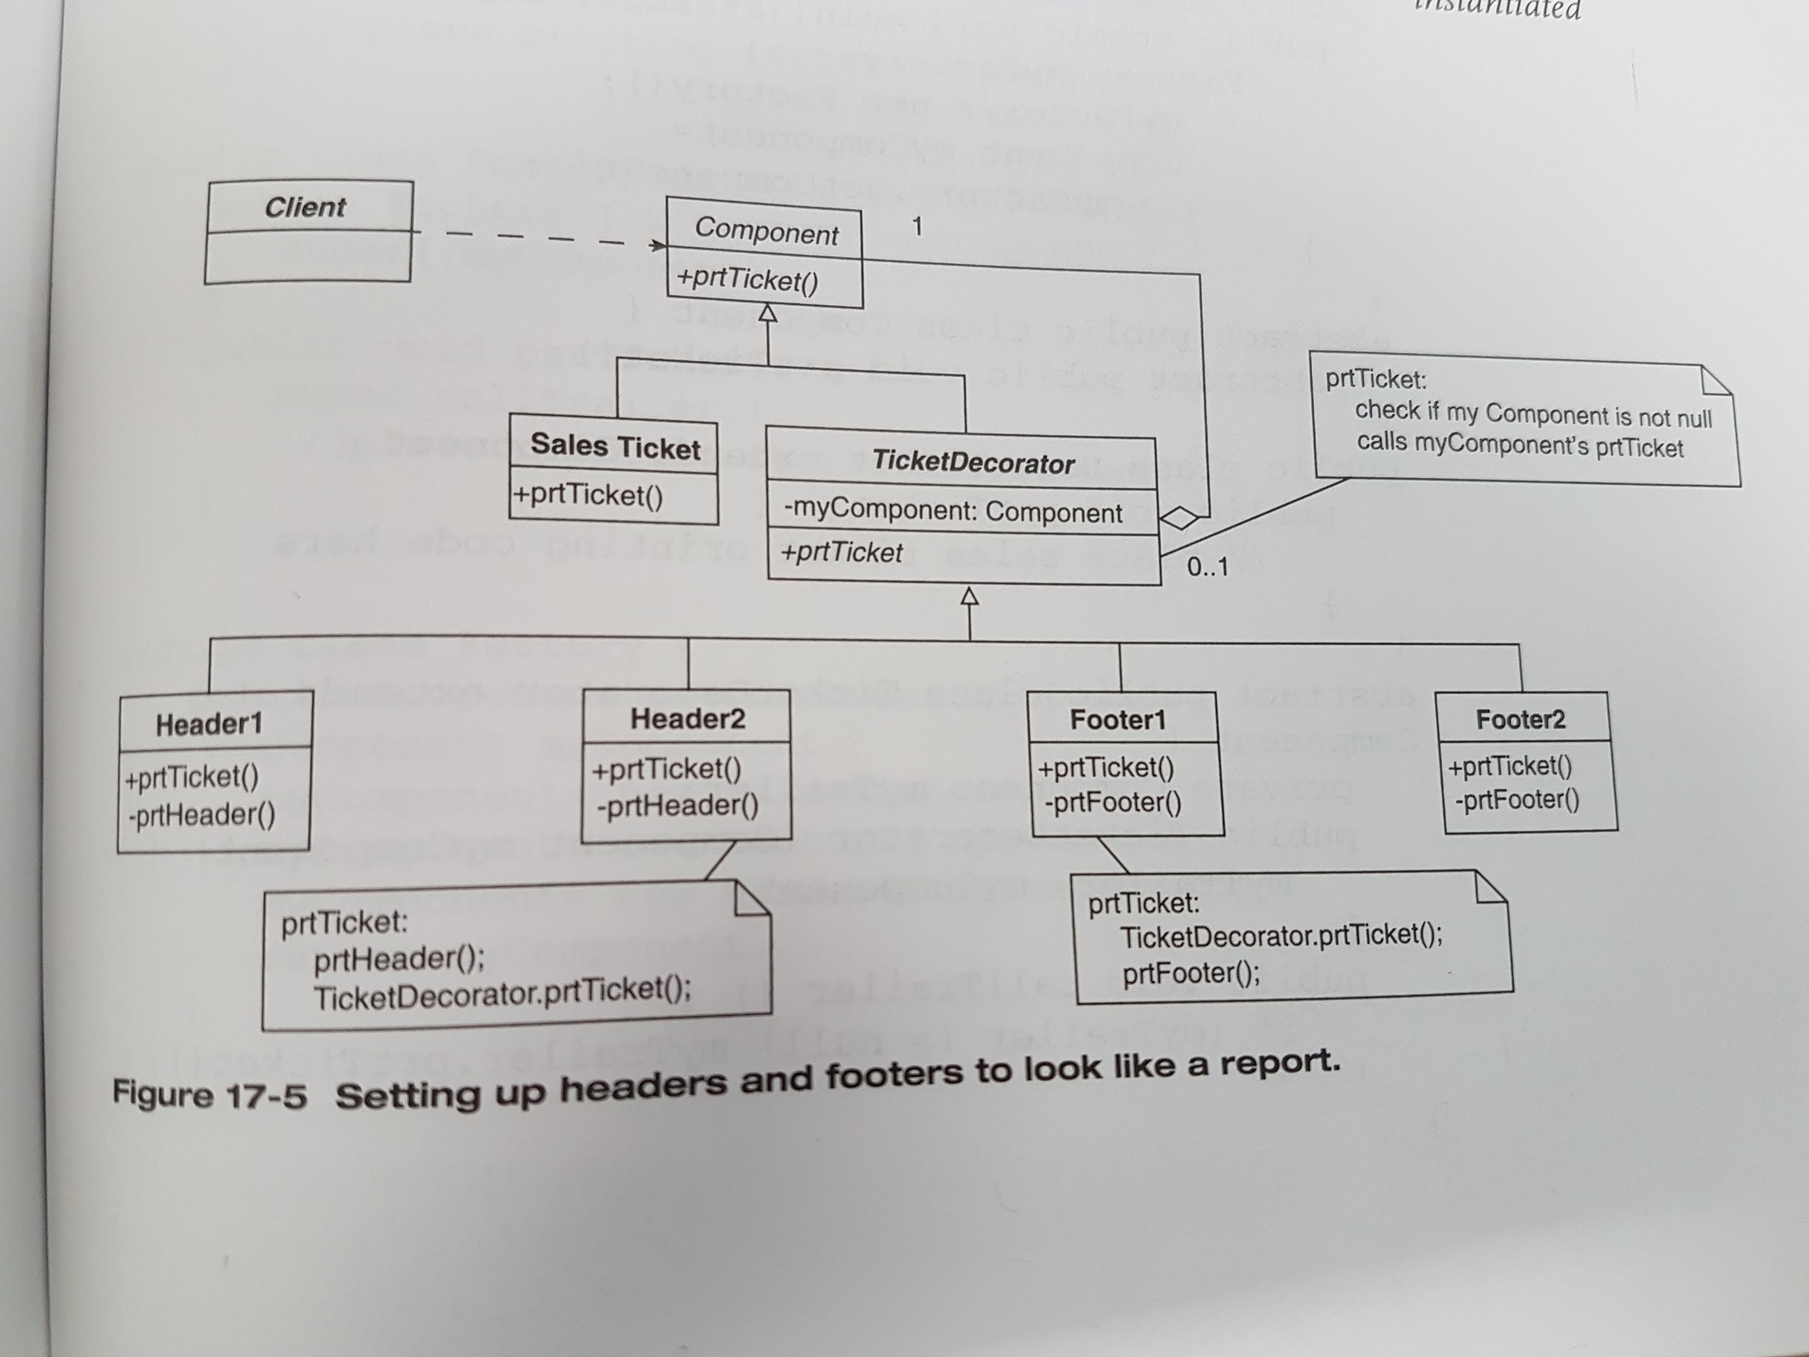

Decorators wrap their trailing object.

The Decorator pattern helps to decompose the problem into two parts:

* how to implement the objects that give the new functionality

* how to organize the objects for each special case

This enables me to separate implementing the Decorators from the object that determines how they are used. This increases cohesion because each of the Decorators is only concerned with the function it adds - not in how it is added to the chain. It also enables me to arbitrarily reorder the Decorators without changing any of their code.

The decoupling of the instantiation of the chain of objects from the Client object that uses it is most typically accomplished through the use of factory objects that instantiate the chains based upon some configuration information.

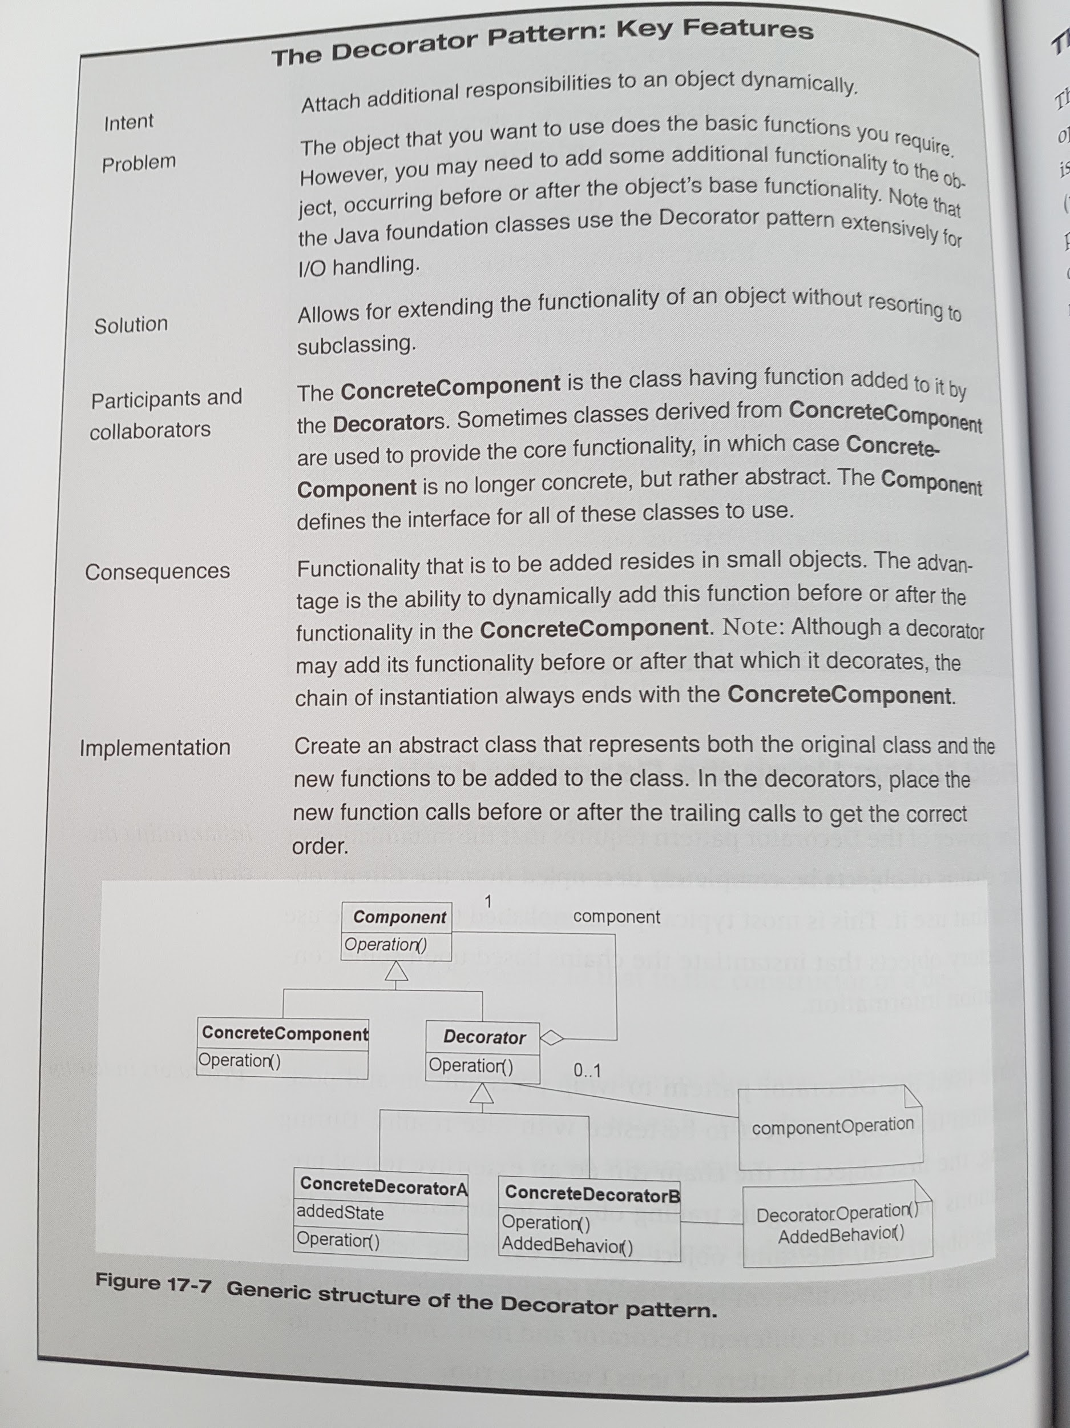

**Part VI - Other Values of Patterns**

**Chapter 18 - The Observer Pattern**

*Creational Patterns* (Abstract F., Singleton, Double-Checked Locking, Factory M.):

* purpose - create or instantiate patterns

* use for - instantiation objects

*Structural* (Facade, Adapter, Bridge, Decorator):

* purpose - bring together existing objects

* use for - handling interfaces; relating implementations to abstractions

*Behavioral* (Strategy):

* purpose - give a way to manifest flexible (varying) behavior

* use for - containing variation

A “fourth” category - ***Decoupling Patterns*** - these patterns’ purpose is to decouple objects from each other (to allow for scalability or increased flexibility).

GoF - the intent of The Observer Pattern: “define a one-to-many dependency between objects so that when one object changes state, all its dependents are notified and updated automatically”

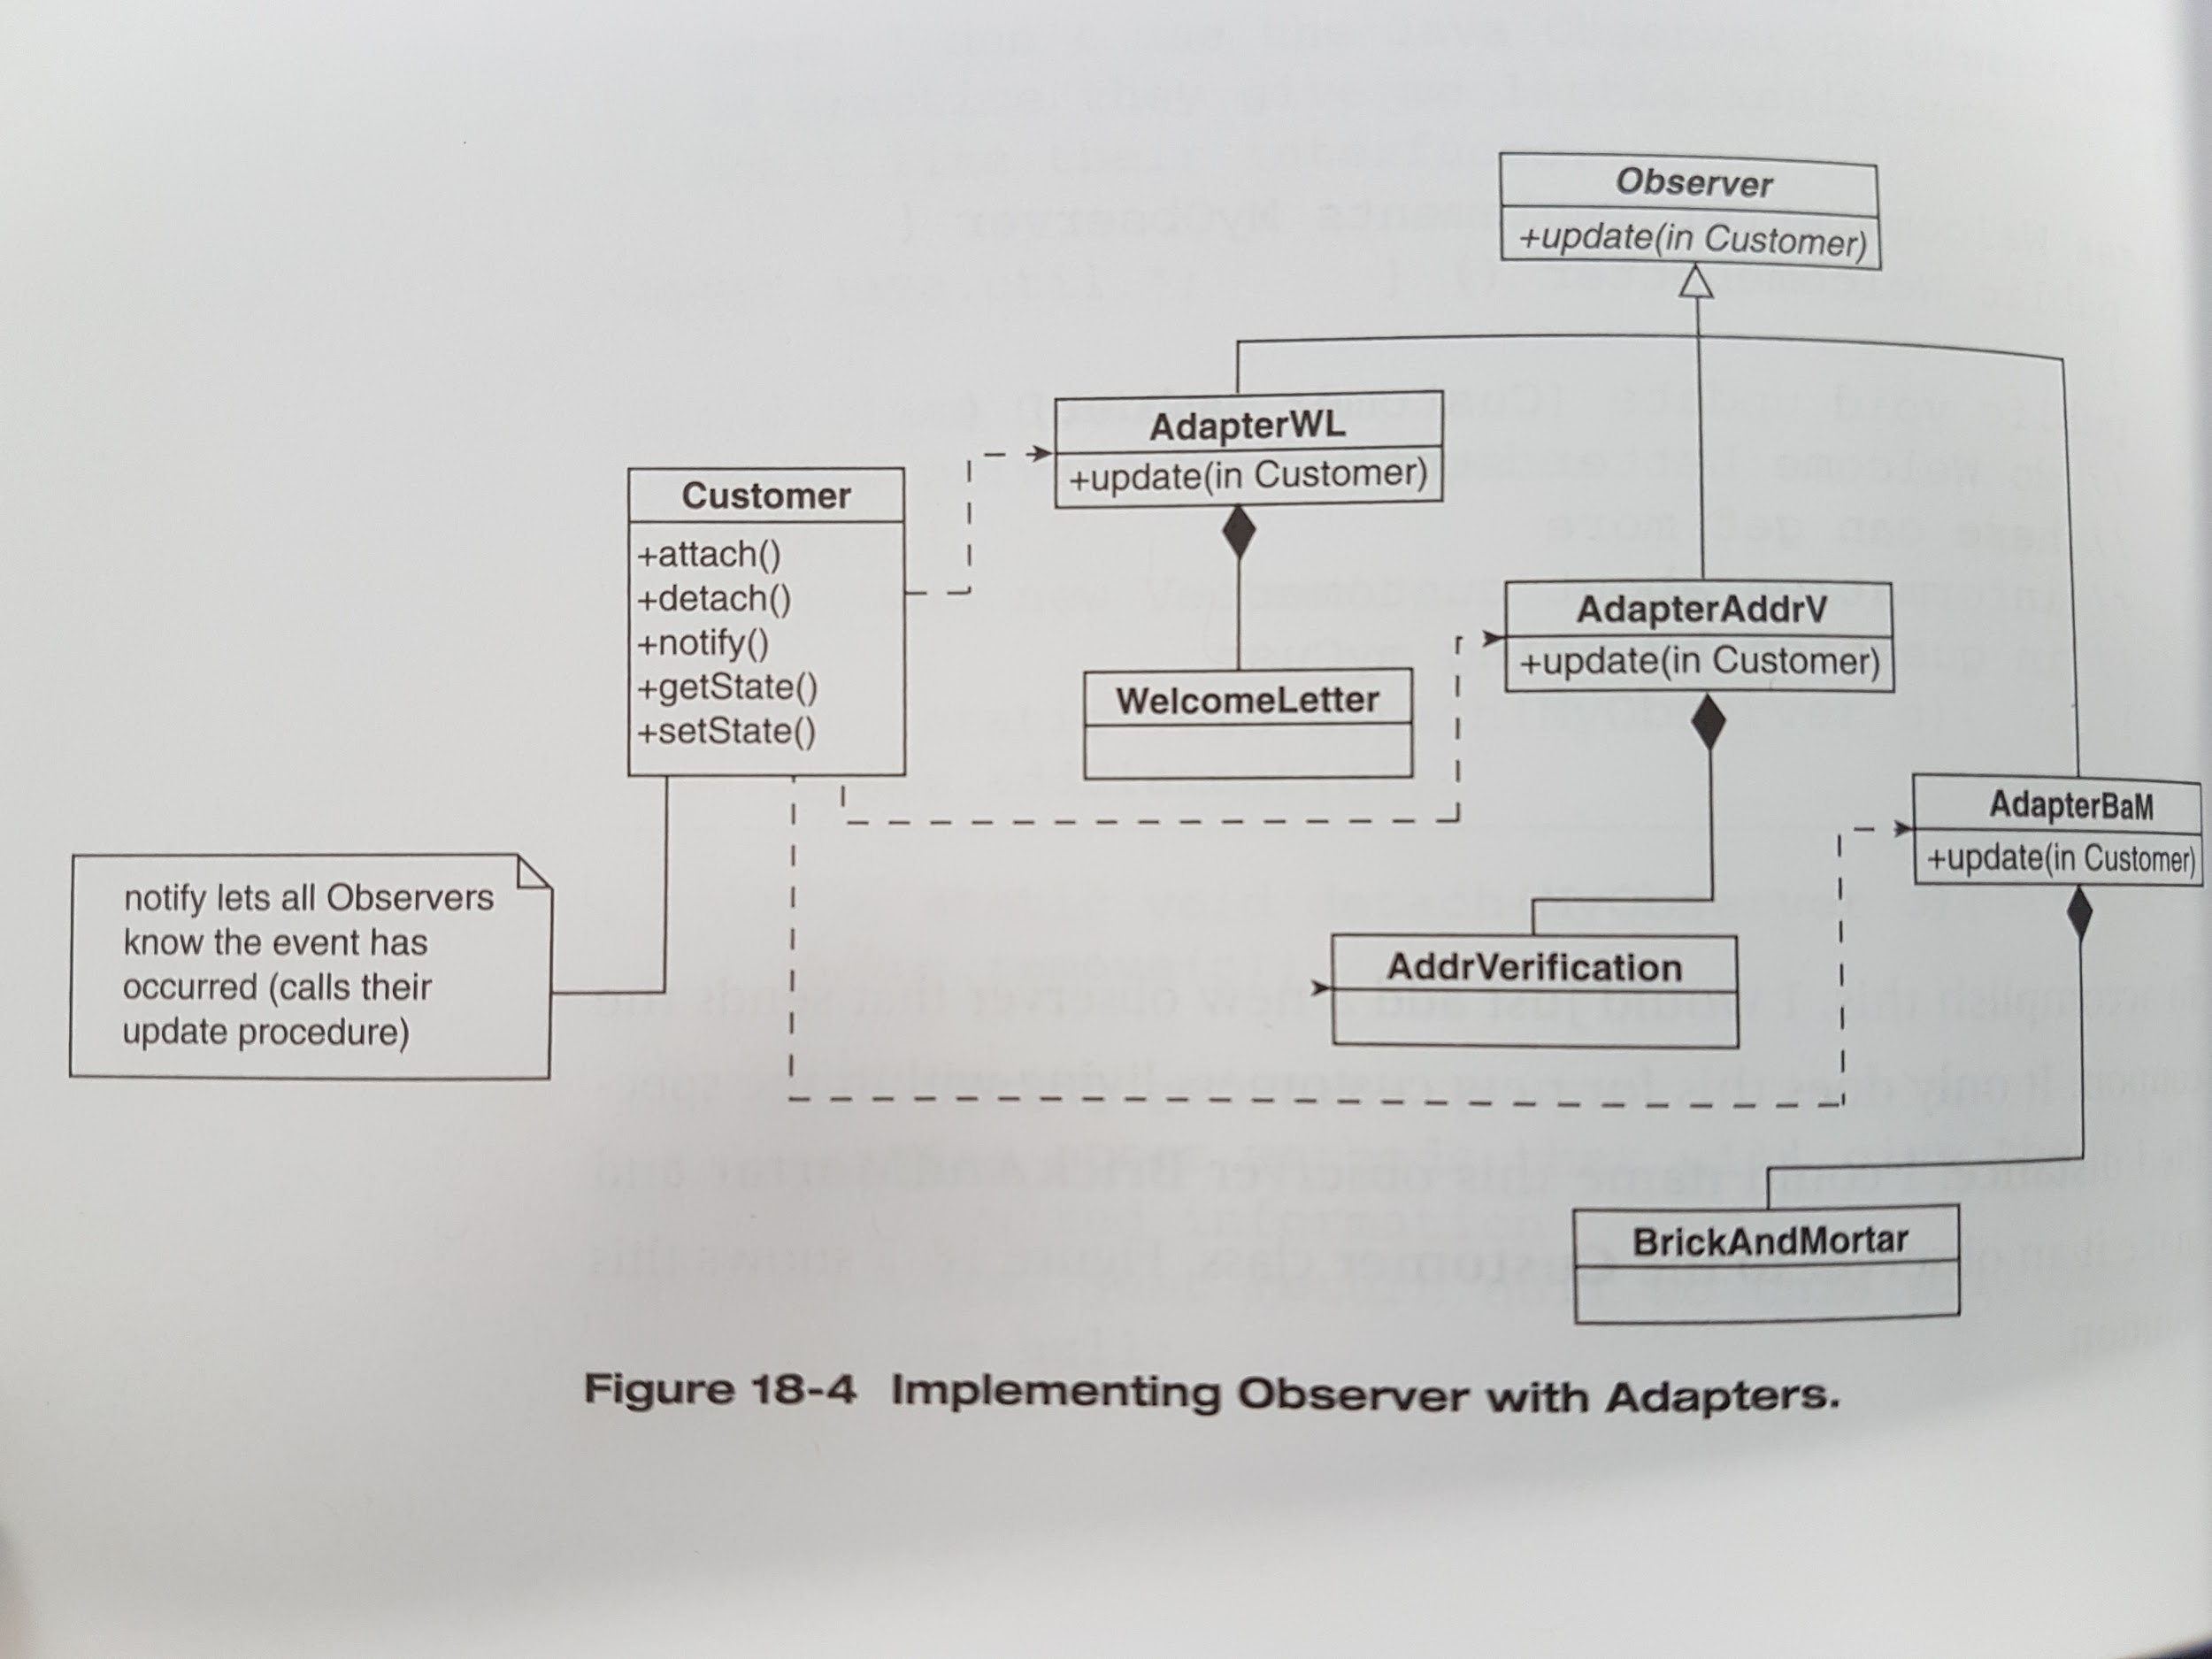

Java contains an implementation of it in its packages. The Observable class and the Observer interface. The observable class plays the role of the subject in the GoF’s description of the pattern. Instead of the methods attach, detach, and notify, Java uses addObserver, deleteObserver, and notifyObserver, but uses update.

When the dependencies are fixed (or virtually so), adding an Observer pattern probably just adds complexity.

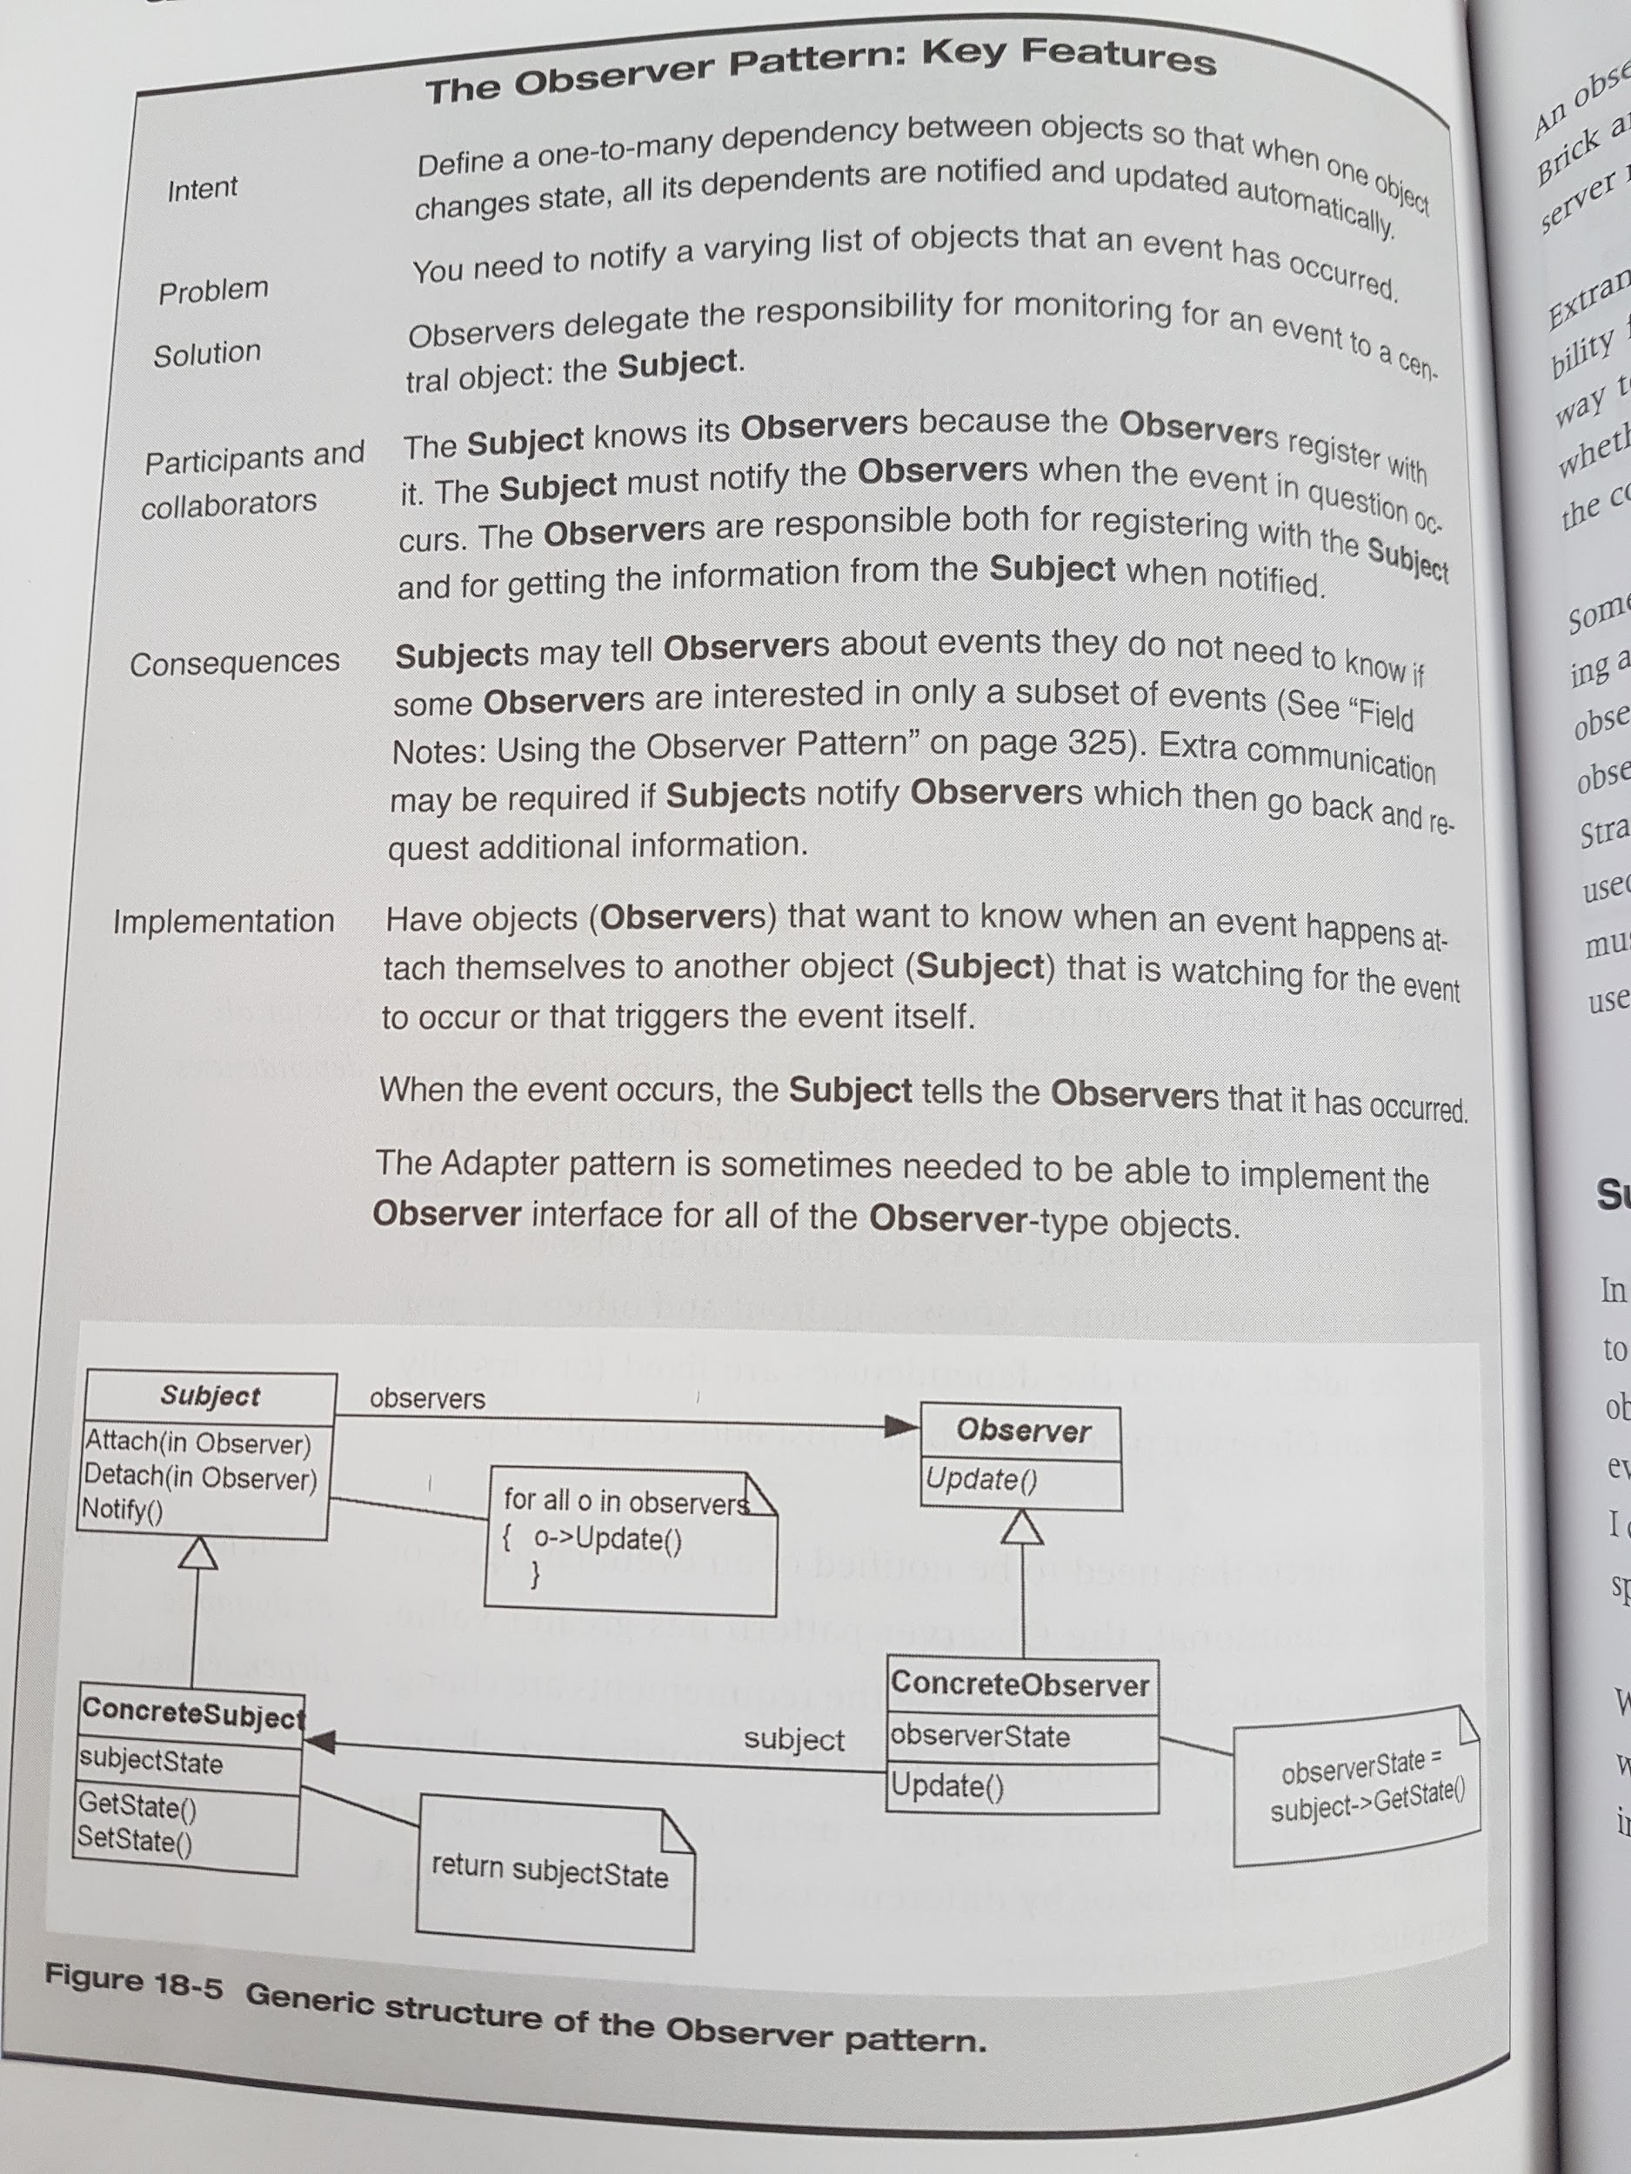

**Chapter 19 - The Template Method Pattern**

The intent according to GoF: “Define the skeleton of an algorithm in an operation, deferring some steps to subclasses. Redefine the steps in the algorithm without changing the algorithm’s structure.”

=> the pattern is about controlling a sequence common to different processes

- the details are varying

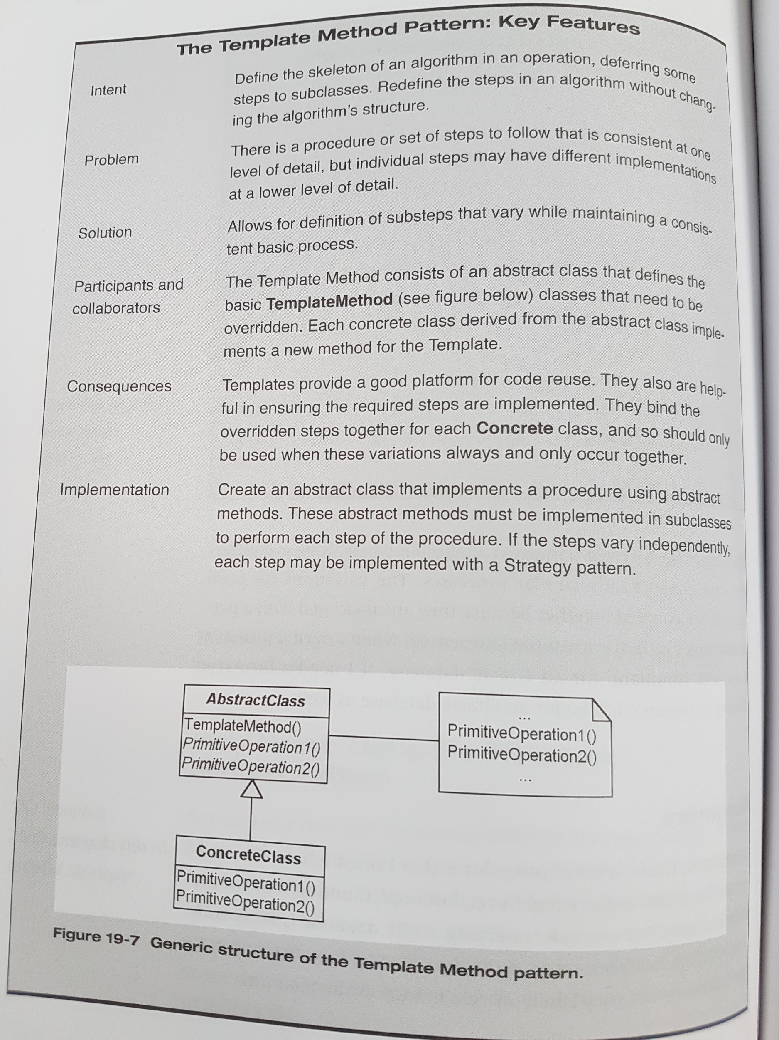

**Part VII - Factories**

**Chapter 20 - Lessons from Design Patterns: Factories**

Factories keep objects cohesive, decoupled, and testable. They help keep the design flexible. They enable splitting the problem into smaller, more manageable pieces.

A factory is a method (static or otherwise), an object, or anything else that is used to instantiate other objects.

Creational patterns that involve factories:

* the Abstract Factory pattern

* the Builder pattern

* the Factory Method pattern

* the Prototype pattern

* the Singleton pattern

Rule: Objects should either make other objects or use other objects, but never both.

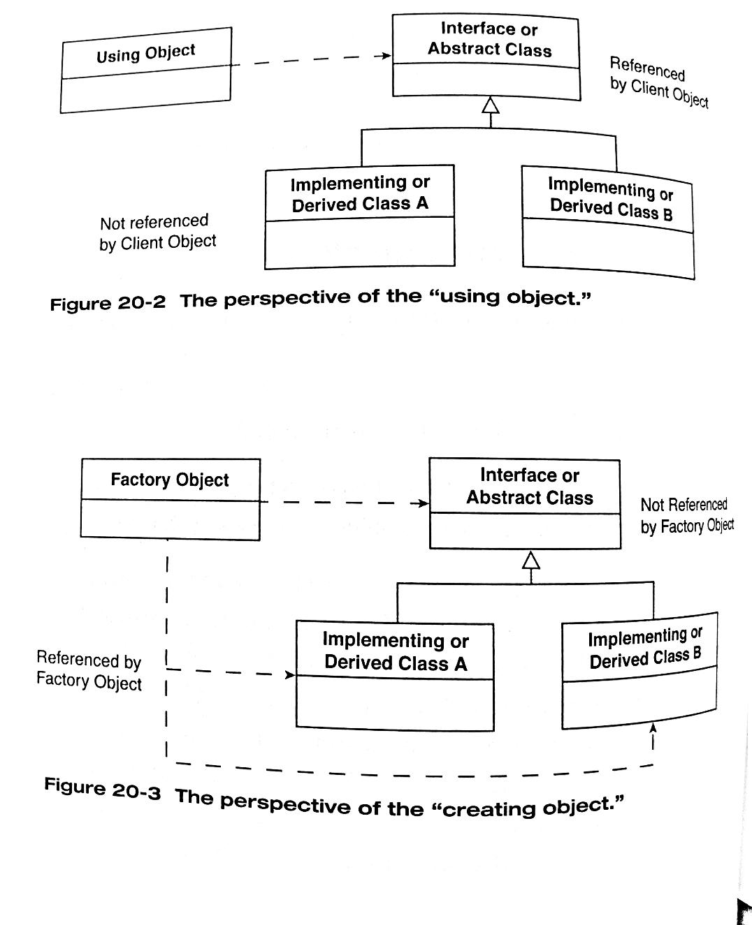

**Chapter 21 - The Singleton Pattern and the Double-Checked Locking Pattern**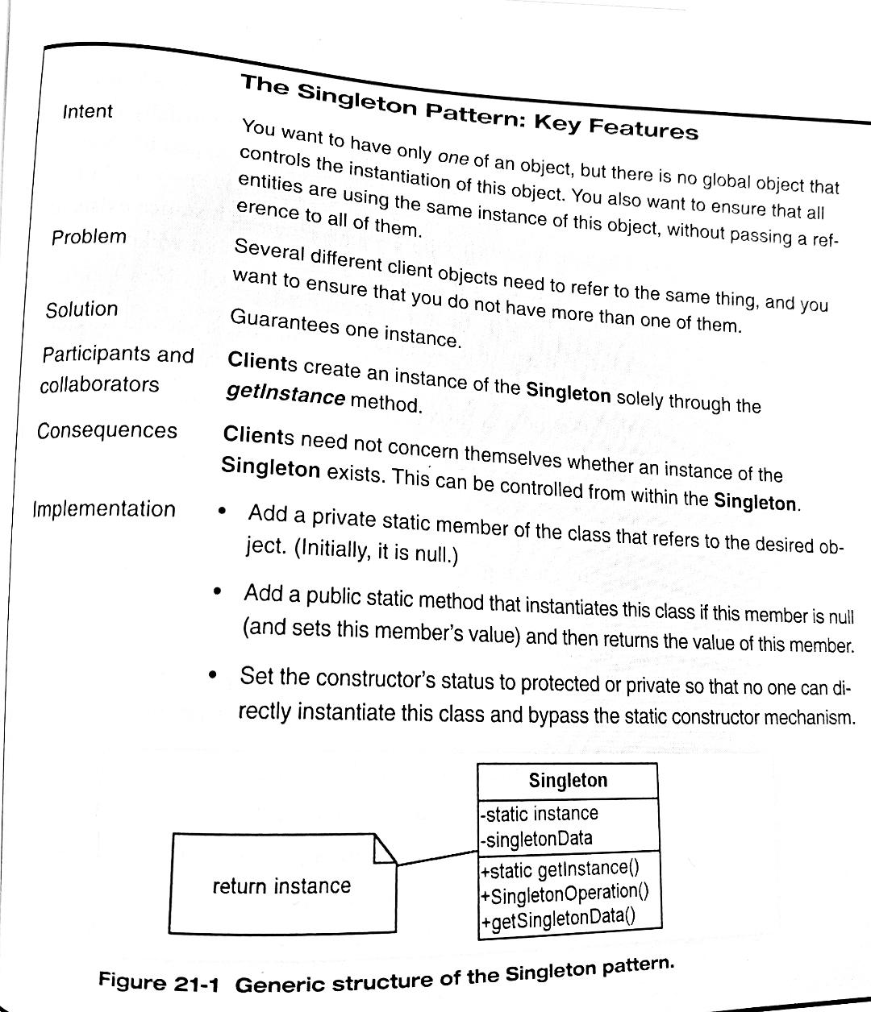

The Singleton pattern is used in single-threaded applications, whereas the Double-Checked Locking pattern is used in multithreaded applications.

GoF, Singleton’s intent: “Ensure a class only has one instance, and provide a global point of access to it.”

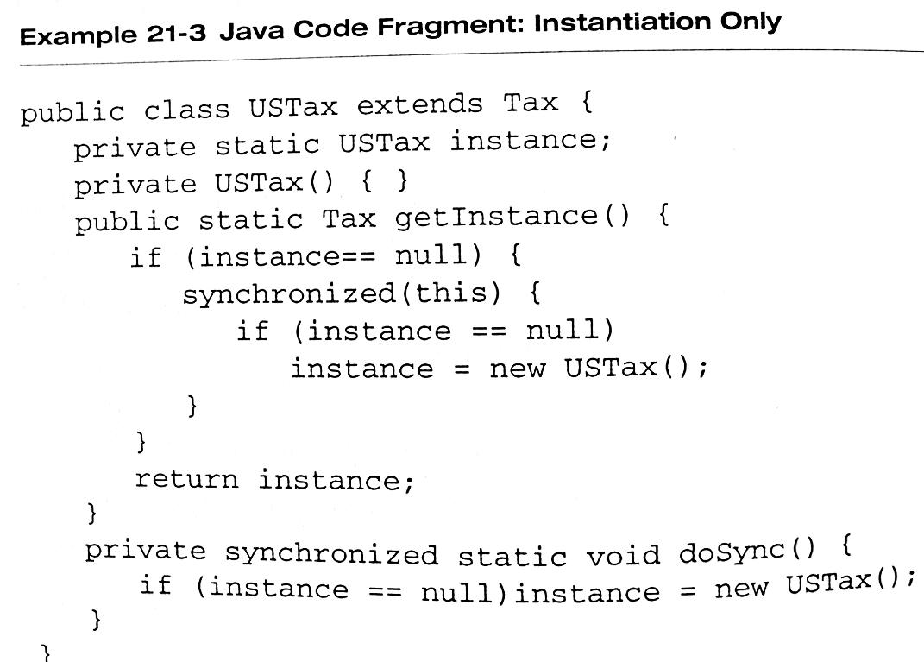

Stateful Singletons should be used sparingly because global data like this can potentially couple disparate parts of the system.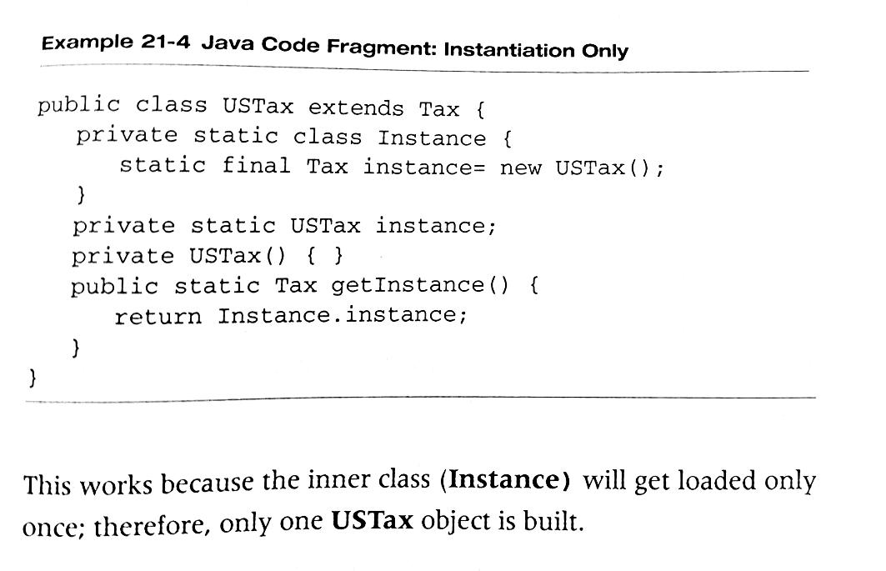

Stateless Facades can be instantiated with a Singleton to avoid having more than one of them. The concrete strategies of the Strategy pattern (when stateless), the concrete implementations of the Bridge (if stateless) can also be instantiated this way. This is true for the objects in many other patterns as well.

**Chapter 22 - The Object Pool Pattern**

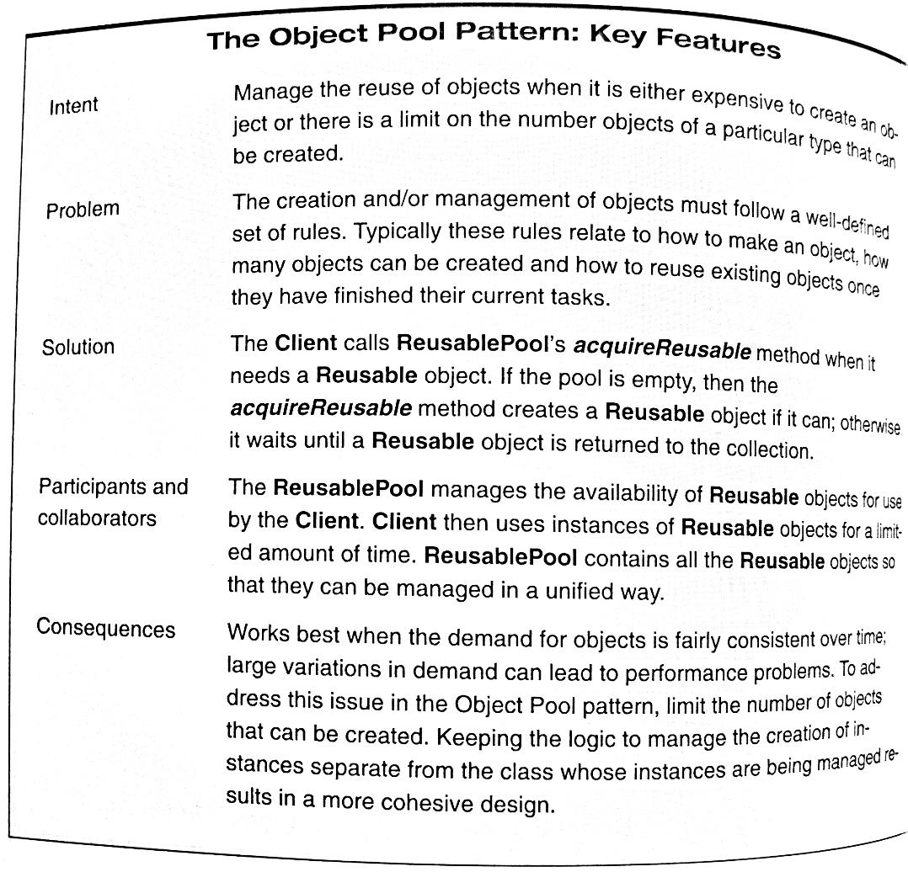

Try to look for ways to insulate yourself from the impacts of changes to the system.

**Steve Maguire - Writing Solid Code**

Gof - The O.P. Pattern intent: “Manage the reuse of objects when it is either expensive to create an object or there is a limit on the number objects of a particular type that can be created.”

The ReusablePool is implemented with a Singleton pattern - the object responsible for managing the object pool must be the only object able to create those objects.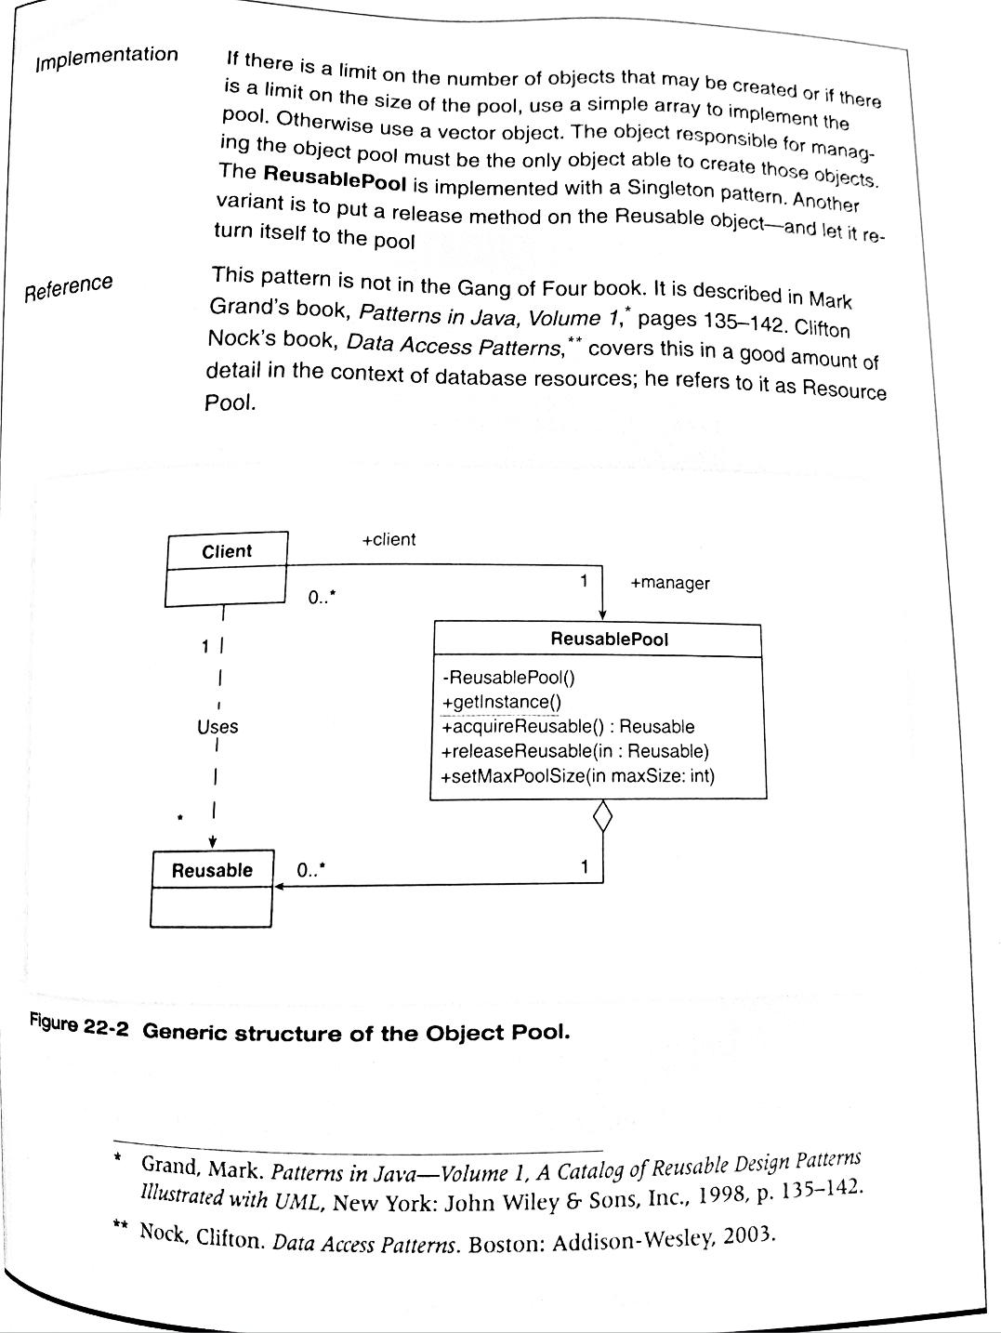

**Mark Grand - Patterns in Java, Volume 1**

**Clifton Nock - Data Access Patterns**

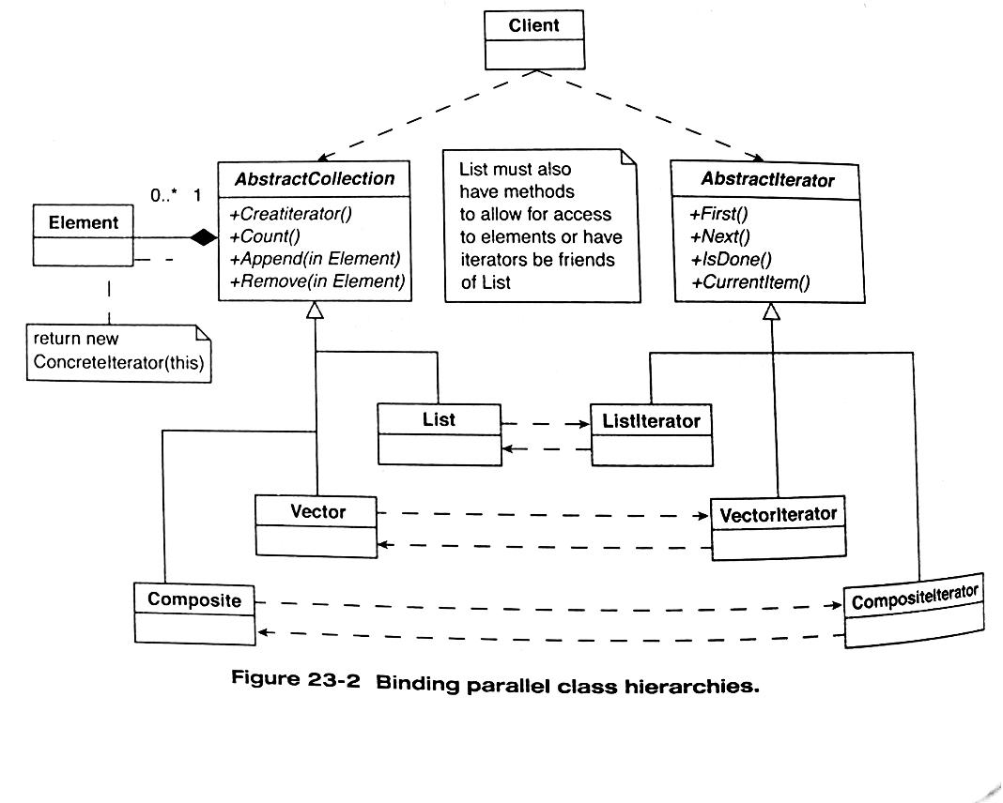

**Chapter 23 - The Factory Method Pattern**

GoF, Factory Method pattern intent: “”Define an interface for creating an object, but let subclasses decide which class to instantiate. Factory Method lets a class defer instantiation to subclasses.

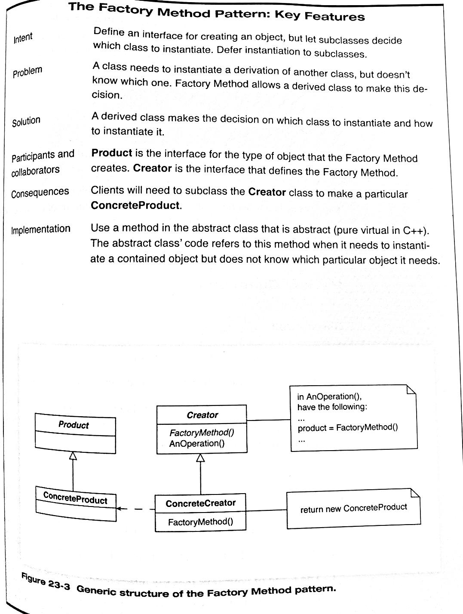

**Chapter 24 - Summary of Factories**

Given any two entities A and B in a system, the relationship should be limited such that *A uses B* or *A creates/manages B*, but never both.

**Part VIII - Endings and Beginnings**

**Chapter 25 - Design Patterns Reviewed: A Summation and a Beginning**

Objects are things with well-defined responsibilities.

Objects are responsible for themselves.

Encapsulation means any kind of hiding (data hiding, implementation hiding, class hiding - behind an abstract class or interface, design hiding, instantiation hiding)

Abstract our variations in behavior and data with commonality and variability analysis.

Design to interfaces.

Think of inheritance as a method of conceptualizing variation, not for making special cases of existing objects.

Keep variations in a class decoupled from other variations in the class.

Strive for loose coupling.

Strive for strong cohesion.

Separate the code that uses an object from the code that creates the object.

Be absolutely meticulous in applying the “once and only once rule”.

Ensure your code is readable by “programming by intention” and by using intention-revealing names.

Consider the testability of your code before coding it.

A pattern describes the forces, motivations, and relationships about a particular problem in a particular context and provides us with an approach to addressing these issues.

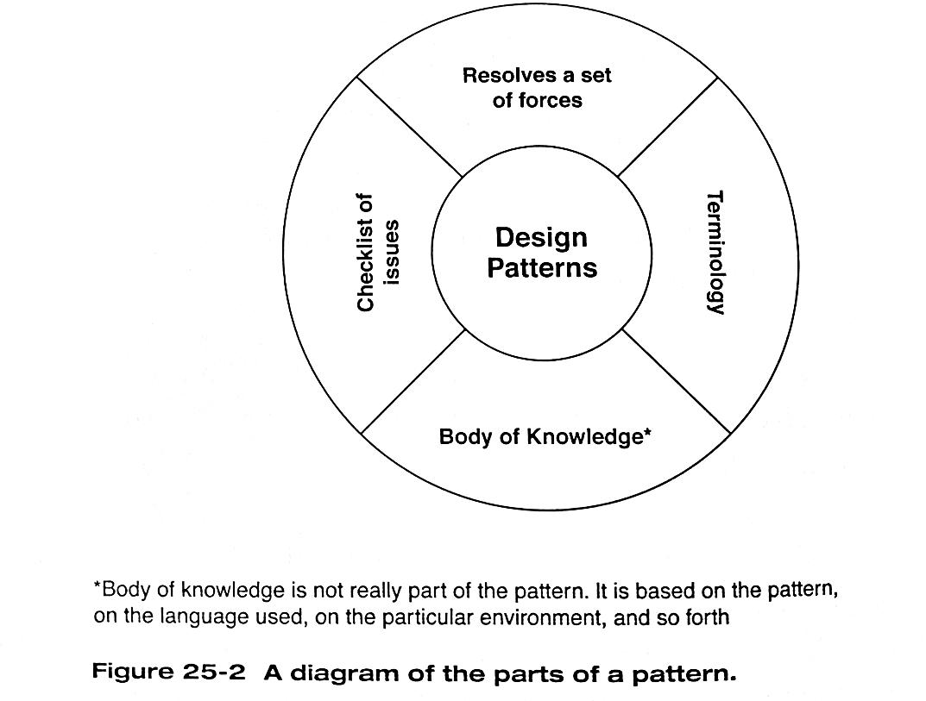

As you learn patterns, it is useful to look for the following forces and concepts:

* What implementations does this pattern hide?

* What commonalities are present in this pattern?

* What are the responsibilities of the objects in this pattern?

* What are the responsibilities between these objects?

* How may the pattern itself be a microcosmic example of designing by context?

**Chapter 26 - Bibliography**

*UML related:*

* M. Fowler, K. Scott - UML Distilled 2nd edition: A brief Guide to Standard Object Modeling Language

*Object-oriented patterns related:*

* M. Fowler - Refactoring: Improving the Design of Existing Code

* R. Martin - Agile Software Development: Principles, Patterns and Practices

* B. Meyer - Object-Oriented Software Construction

*Design patterns:*

* C. Alexander - The Timeless Way of Building

* D. Alur, D. Malks, J. Crupi - J. Core J2EE Patterns: Best Practices and Design Strategies, 2nd Edition

* J. Coplein - Multi-Paradigm Design for C++ (ch. 2-5 for non-C++ developers)

* M. Fowler - Patterns of Enterprise Architecture

* GoF - Design Patterns: Elements of Reusable Object-Oriented Software

* K. Gardner - Cognitive Patterns: Problem-Solving Frameworks for Object Technology (patterns from the perspective of cognitive science and artificial intelligence)

* S. Metsker - Design Patterns Java Workbook

* C. Nock - Data Access Patterns: Database Interactions in Object-Oriented Applications

* D. Schmidt, M. Stal, H. Rohnert, F. Busehmann - Pattern-Oriented Software Architecture, Vol. 2 (multithreading and distributed environments)

*Programming in Java related:*

* P. Bloch - Effective Java Programming Language Guide

* P. Coad - Java Design

* M. Grand - Patterns in Java, Vol 1., 2nd Edition

*Threads in Java related:*

* A. Hollub - Taming Java Threads

* P. Hyde - Java Thread Programming: The Authoritative Solution

* D. Lea - Concurrent Programming in Java: Design Principles and Patterns, 2nd Edition

*eXtreme Programming and Agile related:*

* K. Beck - Extreme Programming Explained: Embrace Change

* A. Cockburn - Agile Software Development

* K. Schwaber, M. Beedle - Agile Software Development with Scrum

*Being a better programmer related:*

* A. Hunt, D. Thomas - The Pragmatic Programmer: From Journeyman to Master

Beyond programming related:

* B. Grieve - The Blue Day Book: A Lesson in Cheering You Up

* N. Hill - Think and Grow Rich

* D. Kundtz - Stopping: How to Be Still When You Have to Keep Going

* O. Mandino - The Greatest Salesman in the World

* P. Pilzer - Unlimited Wealth: The Theory and Practice of Ergonomic Alchemy

* R. Remen - My Grandfather’s Blessings: Stories of Strength, Refuge, and Belonging

* T. Buzan, B. Buzan - The Mind Map Book: How to Use Radiant Thinking to Maximize Your Brain’s Untapped Potential

* T. Cahill - How the Irish Saved Civilization

* C. Dawson - Religion and the Rise of Western Culture

* M. E. Gerber - The E-Myth Revisited: Why Most Small Businesses Don’t Work and What to Do About It

* B. Jensen - Simplicity: The New Competitive Advantage in a World of More, Better, Faster

* S. Lingenfelter - Transforming Culture

* J. P. Spradely - The Ethnographic Interview

* K. Wiig - Knowledge Management Methods